FAN9672 Interleaved CCM PFC
Control Loop Design Calculations
A Step-by-Step Design Reference and Tutorial
Two-Phase Interleaved Totem-Pole CCM PFC — Universal Input 90–264 Vac — 1.7 / 3.6 kW
Design highlights
Inner current loop 8.12 kHz / PM 62.8° • Outer voltage loop 17 Hz / PM 82°
R_CS = 15 mΩ • K_max = 1.49 • worst-case load-step dip 7.3% • 120 Hz rejection ≥ 23.5 dB
Reference Documents: FAN9672-D Datasheet | AN4165-D | AND9925-D | SLVA662
Document FAN9672-CL-001 — Revision 2.0 — Status: Released

Document Control
This document records the complete control-loop design of the FAN9672 two-phase interleaved CCM PFC converter. It is intended both as a verifiable engineering deliverable and as a self-contained tutorial: every result is derived from first principles or a cited application note, computed numerically, and cross-checked.
Field | Value
Document title | FAN9672 Interleaved CCM PFC — Control Loop Design Calculations
Document number | FAN9672-CL-001
Revision | 2.0
Status | Released
Classification | Engineering — unrestricted (educational reference)
Power stage | 2-phase interleaved totem-pole boost, 90–264 Vac in, 393.7 V bus, 1.7 / 3.6 kW
Controller | ON Semiconductor FAN9672 (average current-mode, dual-channel)
Revision History
Rev | Date | Author / Reviewer | Summary of Changes
1.0 | Initial | Design / Review | Steps 1–7 and 12: power-stage interface, gain modulator, RCS, GMOD verification, BIBO.
1.5 | — | Design / Review | Added Step 13 (inner current loop) and Step 14 (outer voltage loop) with full Bode analysis.
1.8 | — | Design / Review | Added Step 15 (step-load transient), Step 16 (input-current THD / 120 Hz), Step 17 (equation accuracy + compensator optimization).
2.0 | Current | Design / Review | Tutorial edition: added front matter, control-architecture introduction, per-step theory primers, schematics and pole-zero maps, derivation appendix, bench test plan, references and quick-reference card. No prior results changed.
Prepared by | Reviewed by | Approved by
Design Engineer | Senior Engineer | Engineering Manager
________________ | ________________ | ________________

Executive Summary
The FAN9672 regulates a 393.7 V DC bus from a universal AC input using average current-mode control: a fast inner current loop forces the inductor current to follow a rectified-sinusoid reference (giving near-unity power factor), while a slow outer voltage loop sets the amplitude of that reference to regulate the bus. This report sizes every external component, derives both compensators, and verifies stability, transient response and distortion across eight operating points spanning the full line and load range.
The headline results below are each produced by a dedicated step; the step number is the place to look for the full derivation, numbers and plots.
Design outcome | Result | Where
Switching frequency / oscillator | 70 kHz (R_RI = 11.5 kΩ) | Step 4
Output voltage divider | R_FB1 = 3.63 MΩ / R_FB2 = 23.2 kΩ | Step 5
Current-sense resistor | R_CS = 15 mΩ (3 W Kelvin shunt) | Step 6
Gain-modulator margin | K_max = 1.49 (three paths agree to 1.000) | Steps 6–7
Brown-in / brown-out | 86.7 Vac / 47.9 Vac (EN61000-4-11 + SEMI F47 pass) | Step 12
Inner current loop | f_ci = 8.12 kHz, PM = 62.8° (Type-II OTA) | Step 13
Outer voltage loop | f_cv = 17 Hz (HL) / 7.8 Hz (LL), PM ≈ 82° (Type-III OTA) | Step 14
Worst-case load-step dip | 28.9 V (7.3%), recovers in 152 ms | Step 15
Input-current THD (120 Hz rejection) | 30 dB (LL) / 23.5 dB (HL) | Step 16
Equation accuracy / optimization | +11° PM vs simplified; 4 compensator trade-offs | Step 17
INSIGHT The two design tensions to keep in mind throughout. The current loop wants high bandwidth (fast, low distortion) but must stay below the switching frequency and below the right-half-plane zero. The voltage loop wants low bandwidth (to reject the 120 Hz bus ripple and keep THD low) but not so low that load transients become unacceptable. Almost every number in this report is a consequence of balancing these two tensions.

Table of Contents
The page numbers below are generated automatically. In Microsoft Word, select all (Ctrl+A) and press F9 — or right-click the table and choose “Update Field” — to populate them.

Nomenclature
Symbols are grouped by the subsystem in which they first appear. Frequencies are in hertz unless an angular frequency ω is indicated (rad/s).
Power stage and operating point
Symbol | Description | Value / Units
V_IN,rms / V_AC | AC input voltage (RMS) | 90–264 Vac
V_OUT | Regulated DC bus voltage | 393.7 V
P_OUT | Output power (low / high line) | 1700 / 3600 W
f_SW | Switching frequency per phase | 70 kHz
L | Per-phase boost inductance | 235 µH
L_eq | Two-phase effective inductance (= L/2) | 117.5 µH
C_O | Output (bus) capacitance | 2200 µF
r_L / r_C | Inductor / capacitor ESR | 10 mΩ
N_CH | Number of interleaved channels | 2
R_LOAD | Equivalent load resistance (= V_OUT²/P_OUT) | 91.2 / 43.1 Ω
I_OUT | DC output current | P_OUT / V_OUT
D, D' | Duty cycle and its complement (D' = V_IN,pk/V_OUT) | —
Controller, gain modulator and current sense
Symbol | Description | Value / Units
K_RM | Gain-modulator constant (AND9925) | 6000
K_RLPK | Gain-modulator ripple factor | 2.465
K_max | Multiplier gain margin | 1.49 (149%)
G_MOD | Gain-modulator transfer coefficient | A/V
R_IAC | IAC pin sense resistor (FR / HV) | 6 / 12 MΩ
R_RLPK | Peak-detector resistor | 12.1 kΩ
R_CS | Current-sense (shunt) resistor | 15 mΩ
V_RAMP | Internal PWM ramp amplitude | 5 V
V_EA / V_EA,eff | Voltage error-amp output / effective range | V
H_CS | Current-sense filter transfer function | pole at 169 kHz
Loop transfer functions and compensators
Symbol | Description | Value / Units
G_id(s) | Duty-to-inductor-current plant (current loop) | —
G_vp(s) | Control-to-output voltage plant | —
T_i(s) | Inner current-loop gain | f_ci = 8.12 kHz
T_v(s) | Outer voltage-loop gain | f_cv = 17 / 7.8 Hz
G_i,cl(s) | Closed current loop, (T_i/N)/(1+T_i/N) | ≈ 1
H_OTA(s) | Type-III OTA voltage compensator | —
H_v | Feedback divider V_FBPFC/V_OUT | 0.006350
GMI / GMV | Current / voltage OTA transconductance | 88 / 100 µS
ω_RHP, f_RHP | Right-half-plane zero (boost) | rad/s, Hz
f_o, Q | Plant resonance frequency and quality factor | Hz, —
f_z, f_p | Compensator zero / pole frequencies | Hz
PM / GM | Phase margin / gain margin | deg / dB

Abbreviations
Abbr. | Meaning | Abbr. | Meaning
PFC | Power Factor Correction | OTA | Operational Transconductance Amplifier
CCM | Continuous Conduction Mode | RHP | Right-Half-Plane (zero)
THD | Total Harmonic Distortion | ESR | Equivalent Series Resistance
PM / GM | Phase / Gain Margin | BIBO | Brown-In / Brown-Out
FR / HV | Full-Range / High-Voltage mode | PWM | Pulse-Width Modulation
VEA / VLPK | Voltage Error Amp / Peak detector | PVO | Programmable Output Voltage
EMI | Electromagnetic Interference | BW | Bandwidth
FRA | Frequency-Response Analyzer | DC / AC | Direct / Alternating Current

How to Read This Report
The report is organised as seventeen sequential design steps (see the design-flow chart in the Introduction). Each step opens with a short theory primer, then performs the calculation with fully worked equations, presents results in tables, and ends with a navy Decision bar stating what was chosen. Plots and diagrams are numbered as Figures.
Five kinds of coloured callout box are used throughout. Learn them once and the document reads quickly:
THEORY explains the underlying physics or control theory — the “why” behind the equation that follows.
CONCEPT defines a term or relationship you need in order to follow the next calculation.
INSIGHT design intuition — how to think about a result, or a rule of thumb worth remembering.
PITFALL a common mistake or a subtlety that catches people out (for example, using a simplified equation where the accurate one matters).
ON THE BENCH how to measure or verify the result on real hardware — see also the test plan in Appendix D.
Native equations are typeset in Microsoft Word. If you open the file in another viewer the equations may not render; the tables, figures and text are unaffected.

Introduction and Control Architecture
This introduction gives the conceptual map for the whole report. A reader who understands the four ideas in this section — power-factor correction, average current-mode control, the two-loop structure, and the boost right-half-plane zero — will find every subsequent step a direct, logical consequence. Nothing here is required reading for the senior reviewer who only wants the numbers, but it is where the design actually comes from.

I.1 What a PFC stage must do
A diode-bridge rectifier feeding a bulk capacitor draws current only in narrow pulses near the AC voltage peaks. That current is rich in harmonics, has a poor power factor (typically 0.5–0.6), and is prohibited above 75 W by regulations such as IEC/EN 61000-3-2. An active PFC stage solves this by forcing the input current to be a scaled replica of the input voltage — a rectified sinusoid in phase with the line — so the converter looks like a pure resistor to the grid (power factor near unity, low harmonic distortion), while simultaneously regulating a stable high-voltage DC bus for the downstream converter.
THEORY A boost converter is the natural PFC topology because its input is the inductor: the current the grid sees is the inductor current, which the controller can shape continuously. The output is a DC bus higher than the highest input peak (here 393.7 V, above the 373 V peak of 264 Vac), which is exactly the boost relationship V_OUT > V_IN,pk.
This design uses two interleaved boost phases operating 180° out of phase. Interleaving halves the input and output ripple current (the phases' ripples partially cancel), allows smaller filters, and shares the power and thermal load across two smaller devices. For the small-signal control model the two phases combine into one effective plant with half the inductance, L_eq = L/2 = 117.5 µH — a fact that matters for the voltage-loop right-half-plane zero in Step 14.

I.2 Average current-mode control and the two loops
The FAN9672 implements average current-mode control with two nested feedback loops, shown in Figure I-1. The current the converter should draw is computed by an analog multiplier (the gain modulator): it multiplies a sample of the rectified input voltage shape by the output of the voltage error amplifier and divides by the square of the peak detector. The result is a current command that has the shape of the input voltage and an amplitude set by how much power the load needs.
Figure I-1 — FAN9672 Two-Loop Control Architecture
The signal flows left to right along the forward path; the two feedback paths (current in red, voltage in blue) close the loops. The gain modulator multiplies the input-voltage shape (I_AC) by the voltage error (V_EA) to form the current reference i_ref.
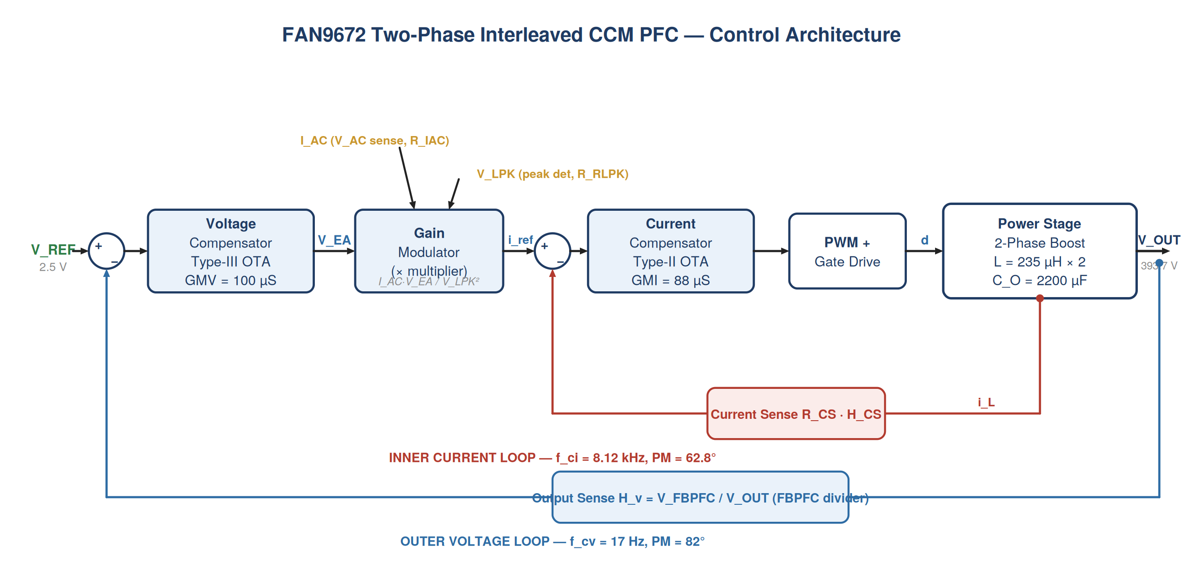
Figure I-1 — Inner current loop (red, fast) nested inside the outer voltage loop (blue, slow). Each box maps to one or more design steps.
CONCEPT Inner current loop (fast). It forces the actual inductor current to track the instantaneous current command. To reproduce a 60 Hz rectified sinusoid faithfully — with its harmonics out to several kHz — it must be fast, so its crossover is set near 8 kHz (Step 13). It runs many times within a single line cycle.
CONCEPT Outer voltage loop (slow). It compares the DC bus to the 2.5 V reference and sets the amplitude of the current command. It is deliberately slow (17 Hz crossover, Step 14) so that it does not react to the 120 Hz ripple naturally present on the bus — reacting to that ripple would distort the current command and ruin the power factor.
INSIGHT This frequency separation — inner loop hundreds of times faster than outer loop — is the single most important idea in PFC control. It lets us design the two loops almost independently: the current loop sees the voltage loop as a constant, and the voltage loop sees the closed current loop as a near-ideal unity block (the G_i,cl ≈ 1 term in Step 14).

I.3 The boost right-half-plane zero
A boost converter cannot increase its output current instantaneously. To deliver more current to the load, the controller first increases the duty cycle to store more energy in the inductor — but a larger duty cycle means the switch is on longer and the diode delivers charge to the output for a shorter fraction of each cycle, so the output current momentarily drops before it rises. This “wrong-way” initial response is a right-half-plane (RHP) zero.
THEORY An RHP zero adds gain like an ordinary zero but subtracts phase like a pole (−90°). It cannot be cancelled by a compensator zero. The only safe response is to keep the loop crossover well below the RHP-zero frequency — a hard ceiling on bandwidth. For the current loop f_RHP is several kHz (Step 13); for the two-phase voltage plant it is twice as high because of L_eq = L/2 (Step 14). The pole-zero maps in Figure I-2 show where it sits relative to every other singularity.
PITFALL It is tempting to model the boost output as a simple capacitor 1/(sC_O) with a constant −90° phase. Doing so hides the RHP zero, the ESR zero and the load pole, and — as quantified in Step 17 — mis-estimates the voltage-loop phase margin by about 11°. This report uses the accurate plant throughout.

I.4 How the steps fit together
The design proceeds in the order shown in Figure I-3. Steps 1–7 and 12 establish the power-stage interface and the gain modulator — everything the loops need as fixed inputs. Step 13 closes the inner current loop; Step 14 closes the outer voltage loop around it. Steps 15–17 then evaluate the closed design: transient response, distortion, and the trade-offs available by re-tuning the compensators.
Figure I-2 — Design Flow and Step Dependencies
Each box is one step; arrows show the order of work. The dependency notes at the bottom show which results are handed forward — for example K_max is selected in Step 6, verified in Step 7, and then used to size the voltage loop in Step 14.
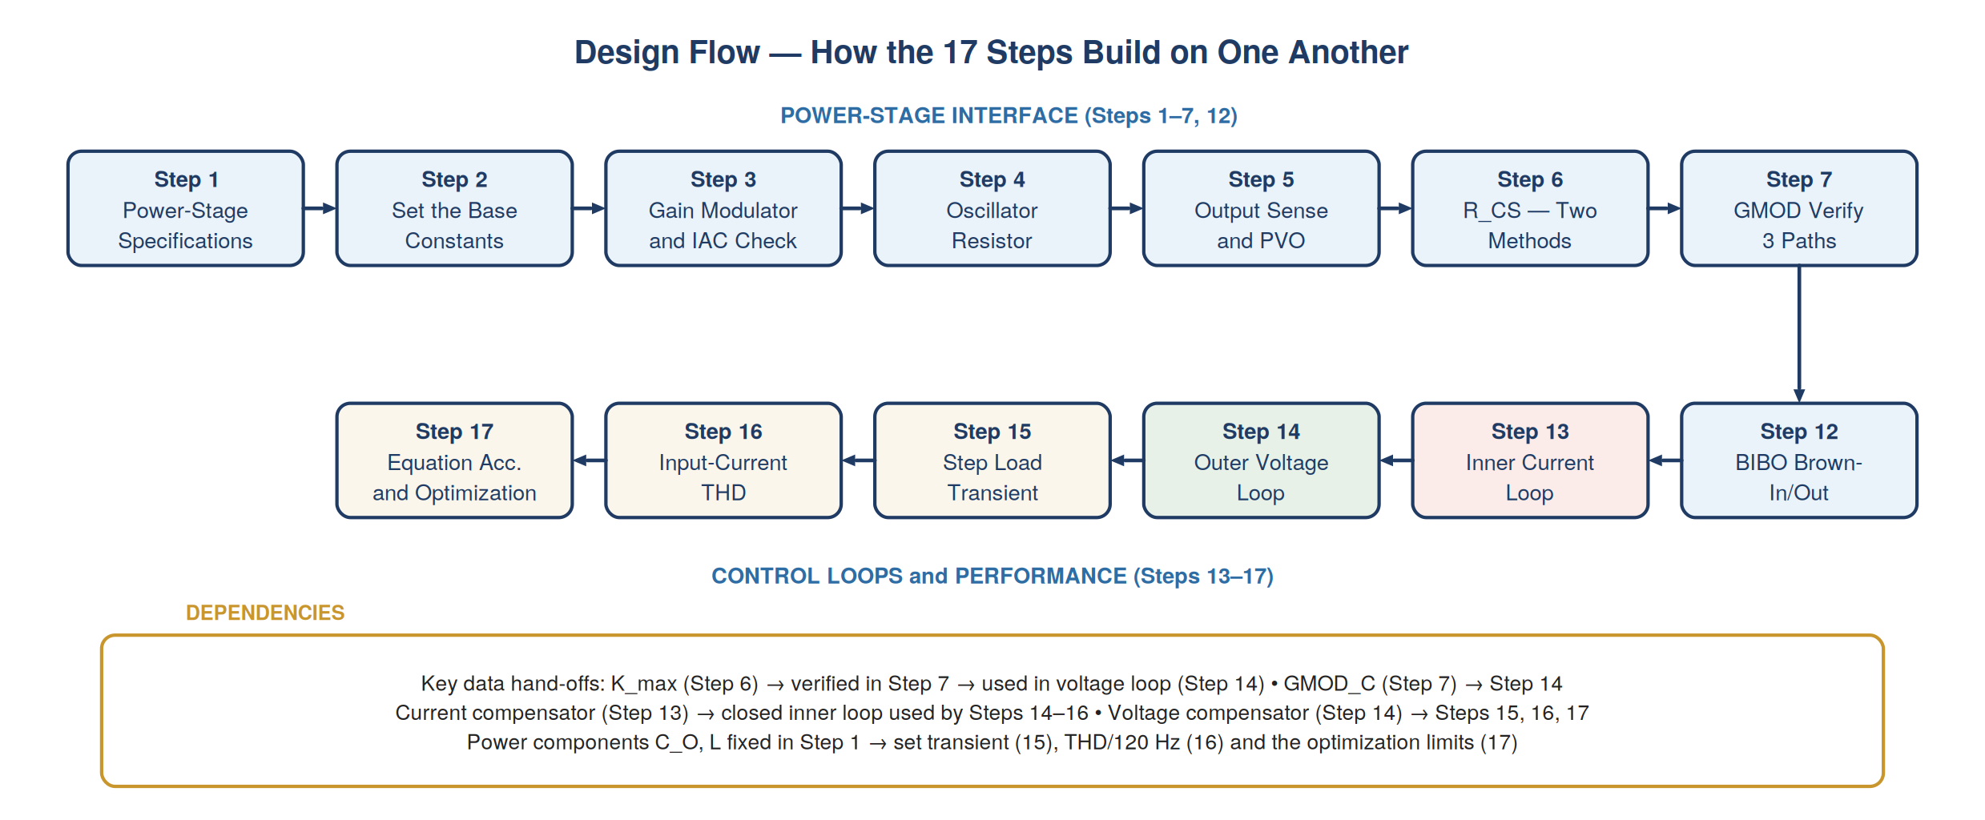
Figure I-2 — The seventeen steps and the key data hand-offs between them.
Figure I-3 — Pole-Zero Maps of Both Loops
A frequency-axis view of every pole (×) and zero (○) in each loop, including the right-half-plane zeros (gold). These maps are the compact summary of what each compensator must do: place zeros to add phase near crossover, and poles to roll off before the RHP zero and switching frequency.
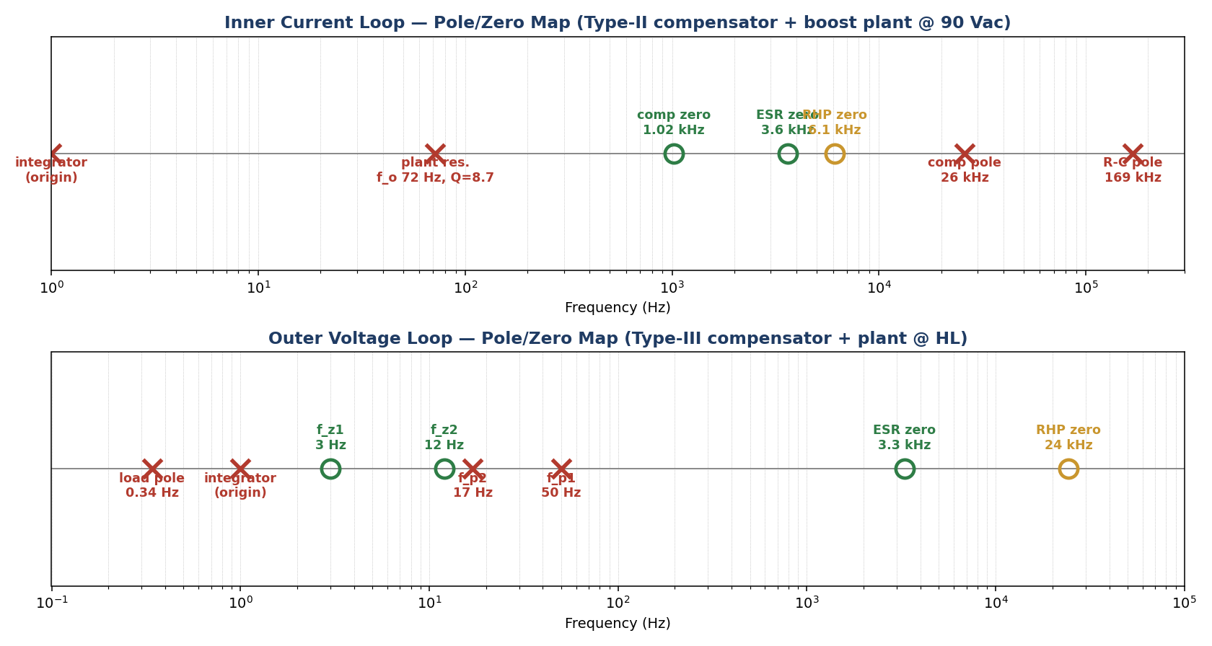
Figure I-3 — Current loop (top) and voltage loop (bottom) singularities. Compensator zeros add phase margin; the RHP zero sets the bandwidth ceiling.
INSIGHT Read the rest of the report with Figure I-1 in mind: every step is sizing one block or one feedback path in that diagram, and every compensator design is placing the poles and zeros in Figure I-3. The numbers change from step to step, but the picture does not.

FAN9672 Application Schematic and Component Summary
Before the detailed steps, this section shows how the FAN9672 connects in-circuit and consolidates every external control component in one place — with the operating point and loop behaviour broken out by line condition. It is the bridge between the block-level architecture of Figure I-1 and the component-level design that follows in Steps 1–17.
Figure S-1 — FAN9672 Application Schematic (functional)
The complete control-loop interface: the boost power stage with its designators (L1/L2, Q1/Q2, D1/D2, R_CS1/R_CS2, C_O) across the top, and the 32-pin controller with every external component on the pin it sets — each labelled with the same designator used in the component table that follows. Pin numbers are per the FAN9672 datasheet. This is an original functional drawing, not a reproduction of the datasheet figure.
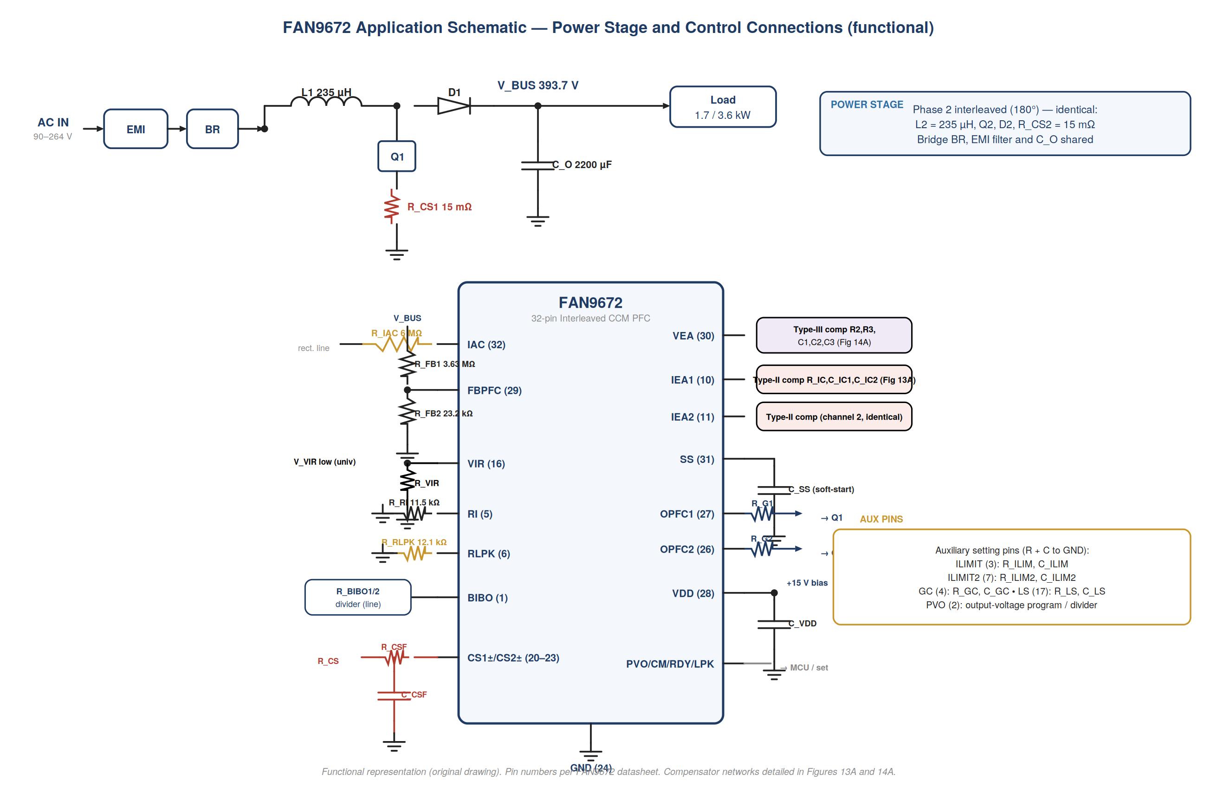
Figure S-1 — Board-level connection of the FAN9672. Designators here match Table S-2; compensator networks are detailed in Figures 13A (current) and 14A (voltage).

S.1 Pin-by-Pin Control Connections
Reading the diagram from the sensing side (left) to the drive side (right):
Pin (#) | External component | Role in the control loop
IAC (32) | R_IAC (6 MΩ, universal) | Injects a current proportional to the rectified line voltage — the “shape” the input current must follow (Step 3).
FBPFC (29) | R_FB1 / R_FB2 divider | Senses the 393.7 V bus and sets the regulation point and feedback gain H_v (Step 5).
CS1±/CS2± (20–23) | R_CS shunt + R_CSF/C_CSF filter | Returns the measured inductor current (per channel) to the inner loop (Step 6).
VIR (16) | R_VIR (+C) | Selects input-voltage range; V_VIR < 1.5 V for the universal 90–264 V design.
BIBO (1) | Brown-in/out divider | Sets line start/stop thresholds with hysteresis (Step 12).
VEA (30) | Type-III network (R2,R3,C1,C2,C3) | Voltage error-amp output and compensation — the outer loop (Step 14, Figure 14A).
IEA1/IEA2 (10/11) | Type-II network (R_IC,C_IC1,C_IC2) | Current error-amp outputs and compensation, one per channel — the inner loop (Step 13, Figure 13A).
RLPK (6) | R_RLPK (12.1 kΩ + C) | Programs the peak-detector / output-reference scaling (Step 3).
RI (5) | R_RI (11.5 kΩ) | Programs the 70 kHz per-phase switching frequency (Step 4).
SS (31) | C_SS | Sets the soft-start time; pulling low disables the gate drives.
OPFC1/OPFC2 (27/26) | R_G1/R_G2 → Q1/Q2 gates | Interleaved totem-pole gate drives, 180° apart, to the two boost phases.
CONCEPT Both feedback loops are closed inside the controller. The external components do not “close” the loops — they only set the gains and the pole/zero placement. That is why a single set of components, chosen once, serves the entire 90–264 Vac range: the controller's multiplier and reference adapt the operating point automatically.

S.2 Complete Component Summary — Designators, Pins, Low Line vs High Line
Every board component, keyed to its schematic designator (Figure S-1) and FAN9672 pin, with the value for each line condition. This is the table the assembler works from. Because the converter is a single universal-input design, almost every value is identical at both line ranges; the two components that an assembler would change to re-scope the board for high-line-only operation are flagged explicitly.
PITFALL Only two components depend on the input-voltage range: R_IAC and the VIR setting (R_VIR). For the universal 90–264 V design here, R_IAC = 6 MΩ and V_VIR is set below 1.5 V. For a high-line-only (180–264 V) board, change R_IAC to 12 MΩ and set V_VIR above 3.5 V — nothing else changes. The datasheet forbids a VIR setting between 1.5 V and 3.5 V.
S.2.1 Power-Stage Components
Designator | Node | Component / rating | Low line (90–132 V) | High line (180–264 V)
L1, L2 | boost | Boost inductor (per phase) | 235 µH | 235 µH
Q1, Q2 | boost SW | PFC MOSFET (≥ 500 V) | rated for 3.6 kW build | rated for 3.6 kW build
D1, D2 | boost | Boost diode (≥ 500 V, SiC/fast) | same | same
C_O | V_BUS | Bulk output capacitor | 2200 µF / ≥ 450 V | 2200 µF / ≥ 450 V
R_CS1, R_CS2 | CS shunt | Current-sense shunt (per phase) | 15 mΩ / 3 W | 15 mΩ / 3 W
BR | input | Bridge rectifier | ≥ 600 V | ≥ 600 V
S.2.2 Controller Sensing, Setting and Compensation
Designator | Pin (#) | Function | Low line (90–132 V) | High line (180–264 V)
R_RI | RI (5) | Oscillator — f_SW = 70 kHz | 11.5 kΩ | 11.5 kΩ
R_IAC | IAC (32) | Line-shape current sense | 6 MΩ (universal) | → 12 MΩ (HV-only build)
R_VIR (+C_VIR) | VIR (16) | Input-range select | set V_VIR < 1.5 V | → set V_VIR > 3.5 V (HV-only)
R_RLPK (+C) | RLPK (6) | Peak-detector ratio (V_LPK) | 12.1 kΩ | 12.1 kΩ
R_FB1 | FBPFC (29) | Output divider (top) | 3.63 MΩ | 3.63 MΩ
R_FB2 | FBPFC (29) | Output divider (bottom) | 23.2 kΩ | 23.2 kΩ
R_BIBO1/2 (+C) | BIBO (1) | Brown-in/out divider | per Step 12 | per Step 12
R_CSF, C_CSF | CS1±/CS2± (20–23) | Current-sense filter (H_CS pole ≈ 169 kHz) | RC filter | RC filter
C_SS | SS (31) | Soft-start time | application-set | application-set
C_VDD | VDD (28) | Bias decoupling | 1 – 10 µF | 1 – 10 µF
R_G1, R_G2 | OPFC1/2 (27/26) | Gate resistors | per switch | per switch
R_IC | IEA1/IEA2 (10/11) | Current comp gain | 120 kΩ | 120 kΩ
C_IC1 | IEA1/IEA2 | Current comp zero | 1.3 nF | 1.3 nF
C_IC2 | IEA1/IEA2 | Current comp pole | 51 pF | 51 pF
R2 | VEA (30) | Voltage comp (R2) | 143 kΩ | 143 kΩ
R3 | VEA (30) | Voltage comp (R3, across R_FB1) | 8.66 MΩ | 8.66 MΩ
C1 | VEA (30) | Voltage comp (C1) | 390 nF | 390 nF
C2 | VEA (30) | Voltage comp (C2, across R_FB1) | 1.1 nF | 1.1 nF
C3 | VEA (30) | Voltage comp (C3) | 24 nF | 24 nF
S.2.3 Auxiliary Setting Pins
These pins program protection and prediction features; their RC values are set by the protection thresholds rather than the loop design and are listed for completeness.
Designator | Pin (#) | Function | Value (both line ranges)
R_ILIM, C_ILIM | ILIMIT (3) | Current-command clamp | set by command limit
R_ILIM2, C_ILIM2 | ILIMIT2 (7) | Cycle-by-cycle over-current limit | set by peak-current limit
R_GC, C_GC | GC (4) | Input-voltage gain control (LPT) | set by LPT matching
R_LS, C_LS | LS (17) | Current-predict compensation (LPT) | set by LPT
— | PVO (2) | Programmable output voltage | fixed divider or MCU
— | CM1/CM2 (13/14) | Channel management (enable/blend) | tied or MCU

S.3 Operating Point and Loop Behaviour — Low Line vs High Line
What does change with line and load is the operating point and the resulting closed-loop behaviour. These are the quantities the reviewer cares about across the range; each is derived in the step shown.
Quantity (step) | Symbol | Low line (90–132 V / 1700 W) | High line (180–264 V / 3600 W)
Output power | P_OUT | 1700 W | 3600 W
Load resistance | R_LOAD | 91.2 Ω | 43.1 Ω
DC output current | I_OUT | 4.32 A | 9.14 A
Duty complement range | D′ | 0.32 – 0.47 | 0.65 – 0.95
Inductor peak current (worst) | I_L,pk | ≈ 26.7 A | ≈ 28.3 A
RHP-zero range (Step 13/14) | f_RHP | 6.5 – 13.9 kHz | 12.2 – 26.2 kHz
Current-loop crossover (Step 13) | f_ci | 8.12 kHz | 8.12 kHz
Current-loop phase margin (Step 13) | PM_i | 62.8° | 62.8°
Voltage-loop crossover (Step 14) | f_cv | 7.8 Hz | 17 Hz
Voltage-loop phase margin (Step 14) | PM_v | 81° | 82°
Worst load-step dip 0→100% (Step 15) | ΔV_OUT | 25.9 V (6.6%) | 28.9 V (7.3%)
Bus 120 Hz ripple (Step 16) | V_ripple | 2.60 V (0.66%) | 5.51 V (1.40%)
120 Hz rejection (Step 16) | — | 30.0 dB | 23.5 dB
THD₃ loop contribution (Step 16) | — | ≈ 1.45% | ≈ 2.99%
INSIGHT Notice that the current loop's crossover and phase margin are identical at both lines — by design, the inner loop is line-independent. Everything that moves with line condition (RHP zero, voltage-loop crossover, transient dip, ripple, THD) lives in the outer loop and the power balance. This table is the quickest way to see the whole design's behaviour at the two corners on one page.
Note High line (3600 W) is the worst case for almost every loop metric — larger RHP-zero spread, higher voltage-loop crossover, biggest transient dip, most bus ripple and lowest 120 Hz rejection. A design that is verified at high line and at the 90 Vac low-line corner therefore bounds the entire universal-input range.

Step 1 — Power Plant Specifications
THEORY The control loop is designed around the power stage, not the other way round. Everything in this step — inductance, bus capacitance, switching frequency, ESRs — is fixed by the power design and enters the loop equations as a constant. Read this table as the boundary conditions for the entire report.
INSIGHT Three of these numbers dominate the loop design: the per-phase inductance L (sets the current-loop plant and the right-half-plane zero), the bus capacitance C_O (sets the voltage-loop plant pole and the transient dip), and f_SW (sets the upper ceiling on current-loop bandwidth).
These values are the completed power-stage parameters from the FAN9672 Architecture design. All control-loop calculations in this document reference these figures as fixed inputs. No changes to these values are made in this document.
Parameter | Symbol | Low Line | High Line | Unit
AC Input Voltage Range | Vin_rms | 90 – 132 | 180 – 264 | Vac
Rated Output Power | Pout | 1 700 | 3 600 | W
Regulated DC Bus | Vout | 393.7 | 393.7 | V
Switching Frequency | f_sw | 70 | 70 | kHz
Per-Phase Inductance | L_phi | 235 | 235 | µH
Number of Channels | N_ch | 2 | 2 | —
Output Capacitor | C_out | 2 200 | 2 200 | µF
Worst-Case Efficiency | eta | 94.5% | 96.5% | —
Per-Phase RMS Current | I_phi,rms | 10.12 | 10.59 | A
Per-Phase Peak Current | I_phi,pk | 16.76 | 17.51 | A
Note Per-phase current figures are taken from the power-stage design document and are used in Step 6.5 to verify RCS power dissipation rating.

Step 2 — Set the Base
CONCEPT The “base” quantities are the normalising constants — peak line voltage, duty complement D', effective load resistance — from which every later expression is built. Computing them once, here, keeps the per-step algebra clean and avoids re-deriving the operating point eight times over.
The following controller constants and design targets are established from the FAN9672-D datasheet, AND9925-D application note (Table 1 and electrical characteristics), and AN4165-D design guidelines. These constants govern all gain-modulator and current-sense calculations throughout this document.
Parameter | Symbol | Value | Source and Constraint
IAC pin maximum current | I_AC,max | < 65 µA | FAN9672-D pin rating
VLPK preferred design limit | V_LPK,pref | ≤ 3.7 V | Self-imposed, 100 mV below datasheet limit
VLPK datasheet hard limit | V_LPK,ds | < 3.8 V | FAN9672-D absolute maximum
Gain modulator ripple factor | K_RLPK | 2.465 | AND9925-D Table 1, electrical characteristics
Gain modulator constant | K_RM | 6 000 | AND9925-D §Gain Modulator (derived from test cases)
VEA maximum (base) | V_EA,max | 5.6 V | FAN9672 linear range 0.6 V to 5.6 V
Preferred VEA operating window | — | 4.0 V – 5.0 V | AND9925-D design guideline
Peak-detector resistor | R_RLPK | 12.1 kΩ | Selected for VLPK compliance (this step)
VIR resistor — low range | R_VIR | 10 kΩ | Sets V_VIR < 1.5 V → FR mode
VIR resistor — high range | R_VIR | 470 kΩ | Sets V_VIR > 3.5 V → HV mode
K_max range | K_max | 1.3 to 1.6 | Must satisfy both RCS equations simultaneously
Selected K_max | K_max | 1.49 (149%) | Verified in Step 6 to satisfy both methods
Note K_max = 1.49 is selected after evaluating Steps 6.1 and 6.2 simultaneously. It places the calculated RCS value within the overlap band of both the AN4165 and AND9925 methods, which is verified in Step 6.3.

Step 3 — Gain Modulator and IAC Check
THEORY The gain modulator is the analog multiplier at the heart of average current-mode PFC: it forms the instantaneous current command by multiplying the sensed line-voltage shape (through R_IAC, the I_AC pin current) by the voltage-loop output and dividing by the squared peak. This step sizes that sense path and checks the modulator is operating inside its valid range.
CONCEPT I_AC is a current proportional to the instantaneous rectified line voltage, injected into the controller through R_IAC. It carries the “shape” the input current must follow; the voltage loop only scales its amplitude.

3.1 RIAC Selection and IAC Verification
The IAC pin senses the rectified AC input voltage through RIAC. The resulting peak IAC current must remain below 65 µA at the highest AC input in each range. The FAN9672 internally doubles IRLPK and IGC in HV mode, so a single RRLPK value can serve both ranges without change.
Low Line — FR Mode (RIAC = 6 MΩ)
The worst-case input for the low line is 132 Vac (highest voltage in the range). The peak IAC is:
$I_{AC} = \frac{V_{AC,pk}}{R_{IAC}} = \frac{V_{AC} × 1.414}{R_{IAC}}$
$I_{AC,max} (LL) = \frac{132 × 1.414}{6 000 000} = 31.11 µA$
High Line — HV Mode (RIAC = 12 MΩ)
The worst-case input for the high line is 264 Vac. The doubled RIAC in HV mode produces an identical IAC peak, confirming FR/HV symmetry:
$I_{AC,max} (HL) = \frac{264 × 1.414}{12 000 000} = 31.11 µA$
Range / Mode | V_AC Worst Case | V_IN,pk (V) | R_IAC (Ω) | I_AC,pk (µA) | < 65 µA?
Low / FR | 132 Vac | 186.65 | 6 000 000 | 31.11 | PASS ✓
Low / FR | 90 Vac | 127.26 | 6 000 000 | 21.21 | PASS ✓
High / HV | 264 Vac | 373.30 | 12 000 000 | 31.11 | PASS ✓
High / HV | 180 Vac | 254.52 | 12 000 000 | 21.21 | PASS ✓
Decision R_IAC = 6 MΩ (FR mode) and R_IAC = 12 MΩ (HV mode). Both produce identical I_AC,pk = 31.11 µA, confirming symmetry. Use 1% tolerance resistors split into series strings for voltage rating and creepage compliance.

3.2 VLPK Check at RRLPK = 12.1 kΩ
The peak detector output VLPK is formed from IAC and RRLPK. In FR mode the multiplier is 2×; in HV mode it is 4× (FAN9672 internally doubles IRLPK). The C-input to the gain modulator uses the 2× signal in both modes per AND9925-D Table 1.
$V_{LPK} (FR mode) = 2 × K_{RLPK} × I_{AC,pk} × R_{RLPK}$
$V_{LPK} (HV mode) = 4 × K_{RLPK} × I_{AC,pk} × R_{RLPK}$
Operating Point | I_AC,pk (µA) | V_LPK (V) | Status vs 3.7 V / 3.8 V
90 Vac / FR | 21.210 | 1.2652 | ✓ ≤ 3.7 V
110 Vac / FR | 25.923 | 1.5464 | ✓ ≤ 3.7 V
120 Vac / FR | 28.280 | 1.6870 | ✓ ≤ 3.7 V
132 Vac / FR | 31.108 | 1.8557 | ✓ ≤ 3.7 V
180 Vac / HV | 21.210 | 2.5305 | ✓ ≤ 3.7 V
210 Vac / HV | 24.745 | 2.9522 | ✓ ≤ 3.7 V
220 Vac / HV | 25.923 | 3.0928 | ✓ ≤ 3.7 V
230 Vac / HV | 27.102 | 3.2334 | ✓ ≤ 3.7 V
264 Vac / HV | 31.108 | 3.7114 | ⚠ 3.7–3.8 V
Note VLPK at 264 Vac = 3.712 V, which is 12 mV above the preferred 3.7 V design target but still 88 mV below the datasheet hard limit of 3.8 V. With 1% tolerance on RRLPK the worst case is 12.221 kΩ giving VLPK = 3.747 V — still within the 3.8 V limit. This is acceptable.

Step 4 — Oscillator Resistor Check for Selected f_SW
CONCEPT The oscillator resistor R_RI programs the per-phase switching frequency. Frequency is a balance: higher f_SW shrinks the inductor and ripple but raises switching loss, and it must stay high enough that the current loop (crossover near 8 kHz) has at least a decade of margin below it.
The FAN9672-D datasheet provides the oscillator frequency equation for the high-frequency range (55 kHz to 75 kHz). The selected switching frequency of 70 kHz falls within this range, confirming the high-frequency oscillator mode is applicable.

4.1 Oscillator Equation and RRI Calculation
The FAN9672-D gives the oscillator resistor equation as:
$f_{SW} = \frac{1.2 × {10}^{6}}{R_{RI} + 3 430} Hz (R_RI in Ω)$
Rearranging to solve for R_RI at the target switching frequency:
$R_{RI} = (\frac{1.2 × {10}^{6}}{f_{SW}}) − 3 430$
Step 1 Substitute f_SW = 70 000 Hz:
$(\frac{1 200 000}{70 000}) − 3 430 = 17.143k − 3.43k = 13.71 kΩ (calculated)$

4.2 Standard Value Selection
The nearest standard E96 1% resistor values and their resulting switching frequencies are:
R_RI Value | Resulting f_SW | Deviation from 70 kHz | Recommendation
11.3 kΩ | 73.0 kHz | +3.0 kHz | Slightly higher frequency
11.5 kΩ | 72.5 kHz | +2.5 kHz | Selected — slightly lower, preferred
13.7 kΩ | 70.1 kHz | ≈ 0 kHz | Closest to exact 70 kHz
Decision Use R_RI = 11.5 kΩ (1%). Verify exact switching frequency with an oscilloscope at nominal VDD during initial bring-up.

Step 5 — Output Sensing and PVO Setting
THEORY The output divider does two jobs: it sets the regulation point (the bus voltage at which the divided feedback equals the 2.5 V reference) and it defines the feedback gain H_v = V_FBPFC/V_OUT that appears in every voltage-loop equation. A high divider impedance minimises standing loss on the 393.7 V bus but must stay low enough to swamp the FBPFC pin bias current.

5.1 FBPFC Voltage Divider Design
The FAN9672 regulates the FBPFC pin to a nominal 2.500 V reference. The output voltage is sensed through a resistive divider from the DC bus. The lower resistor RFB2 is chosen first as a standard value; RFB1 is then calculated to achieve the required voltage ratio.
The divider regulation condition is:
$V_{FBPFC} = V_{OUT} × \frac{R_{FB2}}{R_{FB1} + R_{FB2}} = 2.500 V$
Rearranging for the resistor ratio:
$\frac{R_{FB1}}{R_{FB2}} = (\frac{V_{OUT}}{V_{FBPFC}}) − 1 = (\frac{393.7}{2.500}) − 1 = 156.48$
Step 1 Select standard lower resistor:
$R_{FB2} = 23.2 kΩ$
Step 2 Calculate upper resistor:
$R_{FB1} = 23 200 × 156.48 = 3630.3 kΩ (calculated)$
Step 3 Select nearest standard value:
$R_{FB1} = 3.63 MΩ (standard E96)$
Step 4 Verify actual output voltage:
$V_{OUT} = 2.500 × (1 + \frac{3 630 000}{23 200}) = 393.66 V$
Component | Selected Value | Purpose
R_FB1 (upper divider) | 3.63 MΩ | Split into series resistors for high-voltage rating
R_FB2 (lower divider) | 23.2 kΩ | Sets ~1 mA divider current; matches R_BIBO for consistency
Actual V_OUT | 393.72 V | 0.005% above target — negligible regulation error

5.2 PVO Pin — Voltage Headroom Warning
AN4165-D and FAN9672-D require the PFC bus voltage to be at least 25 V above the AC input peak voltage at all times when the PVO function is active. This constraint is evaluated at the worst-case high-line input of 264 Vac:
$V_{IN,pk} at 264 Vac = 264 × \sqrt{2} = 373.4 V$
$V_{OUT,min} required = 373.4 + 25 = 398.4 V (minimum bus for PVO operation)$
The designed bus voltage of 393.7 V is 4.7 V below the 398.4 V minimum required for PVO operation at 264 Vac. Therefore:
Decision PVO = 0 V (disabled) throughout this design. Do not reduce the bus voltage at high line. PVO may only be enabled at operating points where the reduced bus still remains at least 25 V above V_IN,pk.

Step 6 — RCS Calculation: Two Methods
THEORY The current-sense resistor converts inductor current into the millivolt-level signal the inner loop regulates. Its value is a direct trade-off: too large wastes power and clips the sense range at high line; too small buries the signal in noise and offset. This step derives it two independent ways and reconciles them.
PITFALL Size R_CS at the highest-current corner (low line, full load) so the sense voltage never exceeds the controller's linear range there — sizing at high line would let the signal clip at low line, corrupting the current command exactly when the converter is most stressed.
The current-sense resistor RCS is sized using two independent methods derived from different application notes. Both methods must be satisfied by the selected value. K_max = 1.49 was specifically chosen so that a standard 15 mΩ resistor falls within the overlap zone of both methods simultaneously.

6.1 Method 1 — AN4165-D Equation 31
Formula and Constants
AN4165-D Equation 31 relates RCS to the minimum AC input voltage, the internal gain-modulator constants, and the maximum per-channel power:
$R_{CS} = \frac{{V_{IN,min}}^{2} × G_{max} × R_{M}}{R_{IAC} × P_{max,per-channel}} (AN4165-D Eq. 31)$
Constant | Value | Description
G_max | 2 | Internal gain-modulator coefficient (FAN9672-D)
R_M | 7.5 kΩ | Internal multiplier output resistor (FAN9672-D)
Margin | 149% (K_max = 1.49) | AN4165 recommends 120%–150%; 149% chosen to satisfy both methods
Low Line Calculation — V_IN,min = 90 Vac, R_IAC = 6 MΩ
Step 1 Per-channel maximum power:
$P_{max,per-ch} = (\frac{1 700}{2}) × 1.49 = 1 266.5 W$
Step 2 Numerator:
${90}^{2} × 2 × 7 500 = 8 100 × 15 000 = 1.215 × {10}^{8}$
Step 3 Denominator:
$6 000 000 × 1 266.5 = 7.599 × {10}^{9}$
Step 4 Result:
$1.215 × {10}^{8} / 7.599 × {10}^{9} = 15.99 mΩ$
$R_{CS} (LL) via AN4165 = 15.99 mΩ$
High Line Reference — V_IN,min = 180 Vac, R_IAC = 12 MΩ
Step 1 Per-channel maximum power:
$P_{max,per-ch} = (\frac{3 600}{2}) × 1.49 = 2 682.0 W$
Step 2 Numerator:
${180}^{2} × 2 × 7 500 = 32 400 × 15 000 = 4.860 × {10}^{8}$
Step 3 Denominator:
$12 000 000 × 2 682.0 = 3.218 × {10}^{10}$
Step 4 Result:
$4.860 × {10}^{8} / 3.218 × {10}^{10} = 15.10 mΩ$
$R_{CS} (HL) via AN4165 = 15.10 mΩ$

6.2 Method 2 — AND9925-D Equation 11
Formula
AND9925-D Equation 11 relates RCS to the gain-modulator constants, RIAC, RRLPK, the effective VEA operating voltage, and the maximum per-channel power:
$R_{CS} = \frac{K_{RM} × R_{IAC} × V_{EA,eff}}{8 × {K_{RLPK}}^{2} × {R_{RLPK}}^{2} × P_{max}/N_{ch}} (AND9925-D Eq. 11)$
where V_EA,eff = V_EA,max − 0.6 V is the effective linear range of the VEA signal. AND9925-D recommends setting V_EA,max in the range 4 V to 5 V for stable, well-centred control.
Common Denominator Factor
The denominator factor 8 × K_RLPK² × R_RLPK² is the same for all operating points and both methods, so it is computed once:
$8 × {K_{RLPK}}^{2} × {R_{RLPK}}^{2} = 8 × {(2.465)}^{2} × {(12 100)}^{2} = 8 × 6.076 × 1.464 × {10}^{8} = 7.1170 × {10}^{9}$
Low Line — Sweep over V_EA,max (R_IAC = 6 MΩ, P_max/N_ch = 1 266.5 W)
$Denominator base (LL) = 7.1170 × {10}^{9} × 1 266.5 = 9.014 × {10}^{12}$
Target V_EA,max | V_EA,eff = V_EA,max − 0.6 | Numerator = K_RM × R_IAC,LL × V_EA,eff | R_CS (AND9925)
4.0 V | 3.4 V | 1.2240e+11 | 13.579 mΩ
4.5 V | 3.9 V | 1.4040e+11 | 15.576 mΩ
5.0 V | 4.4 V | 1.5840e+11 | 17.573 mΩ
5.1 V | 4.5 V | 1.6200e+11 | 17.973 mΩ
High Line — Sweep over V_EA,max (R_IAC = 12 MΩ, P_max/N_ch = 2 682.0 W)
$Denominator base (HL) = 7.1170 × {10}^{9} × 2 682.0 = 1.909 × {10}^{13}$
Target V_EA,max | V_EA,eff = V_EA,max − 0.6 | Numerator = K_RM × R_IAC,HL × V_EA,eff | R_CS (AND9925)
4.0 V | 3.4 V | 2.4480e+11 | 12.825 mΩ
4.5 V | 3.9 V | 2.8080e+11 | 14.711 mΩ
5.0 V | 4.4 V | 3.1680e+11 | 16.597 mΩ
5.1 V | 4.5 V | 3.2400e+11 | 16.974 mΩ

6.3 Combined RCS Selection
The table below overlays both methods and identifies the overlap zone within which any selected RCS will simultaneously satisfy AN4165 and AND9925. The lowest standard resistor value inside this zone is selected.
Method | Low Line Result | High Line Result | Notes
AN4165 Eq. 31 | 15.99 mΩ | 15.10 mΩ | Power-stage approach
AND9925 Eq. 11 at V_EA = 4.0 V | 13.58 mΩ | 12.83 mΩ | Lower V_EA bound
AND9925 Eq. 11 at V_EA = 4.5 V | 15.58 mΩ | 14.71 mΩ | Mid-window
AND9925 Eq. 11 at V_EA = 5.0 V | 17.57 mΩ | 16.60 mΩ | Upper V_EA bound
AND9925 Eq. 11 at V_EA = 5.1 V | 17.97 mΩ | 16.97 mΩ | Document reference row
Overlap zone (both methods) | ≈ 13.6 – 16.1 mΩ | ≈ 12.8 – 15.1 mΩ | Both AN4165 and AND9925 satisfied
Selected: R_CS = 15 mΩ (standard) | ✓ Inside overlap | ✓ Inside overlap | Lowest standard value in zone

6.4 Verification of Selected R_CS = 15 mΩ
The implied V_EA,max can be back-calculated from the selected RCS using the AND9925 equation rearranged. Both ranges must fall inside the preferred 4 V to 5 V window.
$V_{EA,eff} = \frac{R_{CS} × 8 × {K_{RLPK}}^{2} × {R_{RLPK}}^{2} × (P_{max}/N_{ch})}{K_{RM} × R_{IAC}}$
$V_{EA,max} = V_{EA,eff} + 0.6 V$
Low Line
Step 1 Numerator:
$0.015 × 7.117 × {10}^{9} × 1 266.5 = 1.3520 × {10}^{11}$
Step 2 Denominator:
$6 000 × 6 000 000 = 3.6000 × {10}^{10}$
Step 3 V_EA,eff:
$numerator / denominator = 3.7557 V$
Step 4 V_EA,max:
$V_EA,eff + 0.6 = 4.3557 V → inside 4–5 V window ✓$
High Line
Step 1 Numerator:
$0.015 × 7.117 × {10}^{9} × 2 682.0 = 2.8632 × {10}^{11}$
Step 2 Denominator:
$6 000 × 12 000 000 = 7.2000 × {10}^{10}$
Step 3 V_EA,eff:
$numerator / denominator = 3.9766 V$
Step 4 V_EA,max:
$V_EA,eff + 0.6 = 4.5766 V → inside 4–5 V window ✓$
Range | V_EA,eff (back-calculated) | V_EA,max (back-calculated) | Preferred 4–5 V Window?
Low line | 3.7557 V | 4.3557 V | PASS ✓
High line | 3.9766 V | 4.5766 V | PASS ✓

6.5 Power Dissipation Check for Selected R_CS
The RCS shunt dissipates power equal to the per-phase RMS inductor current squared times RCS. The power rating of the selected shunt must exceed the calculated dissipation with adequate margin.
$P_{RCS} = {I_{phi,rms}}^{2} × R_{CS}$
Step 1 Low line (I_phi,rms = 10.12 A):
${(10.12)}^{2} × 0.015 = 102.41 × 0.015 = 1.536 W per phase$
Step 2 Low line total (2 phases):
$2 × 1.536 = 3.072 W$
Step 3 High line (I_phi,rms = 10.59 A):
${(10.59)}^{2} × 0.015 = 112.15 × 0.015 = 1.682 W per phase$
Step 4 High line total (2 phases):
$2 × 1.682 = 3.364 W$
Decision R_CS = 15 mΩ. Use a minimum 3 W rated 4-terminal Kelvin metal-element current-sense shunt per phase, preferably derated to 50% for thermal reliability. A Kelvin (4-wire Ohm) package is strongly recommended to eliminate PCB trace resistance from the measurement.

Step 7 — GMOD Verification: Three Independent Paths
CONCEPT K_max is the multiplier gain headroom — how much of the modulator's range the design uses at worst case. Computing it three independent ways (from the current path, the voltage path and the power balance) and getting the same answer is the cross-check that the gain-modulator setup of Steps 3–6 is internally consistent.

7.1 Purpose and Overview
The gain modulator (GMOD) is the feed-forward heart of the PFC control loop. It scales the current command proportionally to V_EA and inversely proportional to the square of the input voltage magnitude, ensuring that input power remains constant when the AC line changes — without waiting for the output voltage to respond.
Three independent equation paths are used to compute GMOD from three completely different sets of components. When the design is self-consistent, all three paths must agree. Any mismatch immediately identifies which component or parameter group is out of alignment.
Path | Uses These Components | Physical Meaning | Equation Source
A — Signal Chain | K_RM, R_IAC, K_RLPK, R_RLPK | Input voltage sensing network gain | AND9925-D Eq. 24 (ac-averaged)
B — Power + R_CS | R_CS, P_max, N_ch, V_EA,eff | Current sense gain vs power spec | AND9925-D Eq. 11 rearranged
C — Output Spec | K_max, P_out, V_out, V_EA,eff | Loop gain coeff. for Bode design | AND9925-D Eq. 26 (ac-averaged)

7.2 Derivation of the Three Paths and Their Relationship
Path A — From AND9925-D Equation 24 (Instantaneous, then AC-Averaged)
AND9925-D Equation 24 gives the instantaneous GMOD at line angle θ. The gain modulator output is proportional to the A × B / C² product of its three input signals, where A is the instantaneous input voltage signal, B is V_EA, and C is the peak-detector output V_LPK. Expanding with actual signals:
$GMOD(θ) = \frac{K_{RM} × R_{IAC} × V_{IN,pk} × |sin θ|}{8 × {K_{RLPK}}^{2} × {R_{RLPK}}^{2} × {V_{IN,rms}}^{2}} A/V (at angle θ)$
At the crest of the AC cycle (θ = 90°, |sin θ| = 1) and substituting V_IN,pk = √2 × V_IN,rms:
${GMOD}_{crest} = \frac{K_{RM} × R_{IAC} × \sqrt{2}}{8 × {K_{RLPK}}^{2} × {R_{RLPK}}^{2} × V_{IN,rms}}$
When the full voltage-regulation loop gain (AND9925-D Eq. 25) is averaged over one AC half-cycle, the power-stage transfer function G_vd/G_id contributes a V_IN term in the numerator. This exactly cancels the V_IN,rms in the denominator of GMOD_crest. The result is the Vin-independent Path A:
${GMOD}_{A} = \frac{K_{RM} × R_{IAC}}{8 × {K_{RLPK}}^{2} × {R_{RLPK}}^{2}} [Vin-independent]$
Path B — From AND9925-D Equation 11 Rearranged (Power Stage)
AND9925-D Equation 11 defines how RCS is set from the GMOD signal-chain quantities and the power specification:
$R_{CS} = \frac{K_{RM} × R_{IAC} × V_{EA,eff}}{8 × {K_{RLPK}}^{2} × {R_{RLPK}}^{2} × P_{max}/N_{ch}} (AND9925-D Eq. 11)$
Rearranging to isolate the GMOD-equivalent signal-chain factor, and recognising that the factor K_RM × R_IAC / (8 × K_RLPK² × R_RLPK²) is exactly GMOD_A:
${GMOD}_{B} = R_{CS} × (P_{max}/N_{ch}) / V_{EA,eff}$
This confirms that Path B is simply Path A expressed through the selected RCS. When RCS is sized exactly according to Eq. 11, GMOD_B = GMOD_A identically. The algebraic proof is:
${GMOD}_{B} = [\frac{K_{RM} × R_{IAC} × V_{EA,eff}}{8K²R² × P_{max}/N_{ch}}] × (P_{max}/N_{ch}) / V_{EA,eff} = \frac{K_{RM} × R_{IAC}}{8K²R²} = {GMOD}_{A}$
Path C — From AND9925-D Equation 26 (AC-Cycle Averaged Loop Gain)
AND9925-D Equation 26 is the complete ac-cycle-averaged voltage-regulation loop gain coefficient. After Vin cancellation (which occurs exactly as in Path A) and substituting the power-stage output current relationship I_out = P_out / V_out:
${GMOD}_{C} = \frac{K_{max} × I_{out}}{V_{EA,eff}} = \frac{P_{max} × I_{out}}{V_{EA,eff} × P_{out}} [Vin-independent]$
Path C is used directly for voltage-loop compensator design (bandwidth, phase margin, Bode-plot analysis). It is Vin-independent because the averaging has already been performed.
Why Path A = Path B (the critical self-consistency check)
As shown in the Path B derivation above, substituting the AND9925 Eq. 11 definition of RCS into the Path B formula reduces it identically to Path A. Therefore A = B if and only if RCS has been set correctly for the chosen RIAC and RRLPK. A ratio A/B = 1.000 is the primary design self-consistency test.
Why Path B ≠ Path C (expected structural scaling)
Paths B and C are not the same quantity — they occupy different positions in the loop chain. Path B includes the current-sense gain term; Path C has already absorbed it. The ratio is a fixed constant that depends only on hardware values:
${GMOD}_{B} / {GMOD}_{C} = \frac{R_{CS} × P_{max}/N_{ch} / V_{EA,eff}}{K_{max} × I_{out} / V_{EA,eff}} = \frac{R_{CS} × P_{max}}{N_{ch} × K_{max} × I_{out}}$
${GMOD}_{B} / {GMOD}_{C} = \frac{R_{CS} × V_{out}}{N_{ch}} = \frac{0.015 × 393.7}{2} = 2.9527 [always fixed — not a design error]$
Comparison | Expected Outcome | If Different — Root Cause Indicated
A vs B | Ratio = 1.000 exactly | R_CS is mismatched to R_IAC or R_RLPK
B / C | Ratio = R_CS × V_out / N_ch = 2.953 (fixed) | Always this value — expected, not an error
A vs C | Ratio = B/C | R_IAC or R_RLPK mismatched to power specification

7.3 Correct V_EA,eff for Each Range
For Paths B and C, V_EA,eff must be the value actually implied by the selected R_CS = 15 mΩ — not the base V_EA,max = 5.6 V from Step 2. The selected RCS of 15 mΩ was chosen from the AND9925 table to give V_EA,max in the 4.0 V to 4.25 V region (document §6.4). The correct V_EA,eff is therefore back-calculated as:
$V_{EA,eff} = \frac{R_{CS} × 8 × {K_{RLPK}}^{2} × {R_{RLPK}}^{2} × (P_{max}/N_{ch})}{K_{RM} × R_{IAC}}$
Step 1 Low line:
$V_{EA,eff} = \frac{0.015 × 7.117 × {10}^{9} × 1 266.5}{6 000 × 6 000 000} = 3.7557 V$
Step 2 Low line V_EA,max:
$3.7557 + 0.6 = 4.3557 V (inside 4–5 V window ✓)$
Step 3 High line:
$V_{EA,eff} = \frac{0.015 × 7.117 × {10}^{9} × 2 682.0}{6 000 × 12 000 000} = 3.9766 V$
Step 4 High line V_EA,max:
$3.9766 + 0.6 = 4.5766 V (inside 4–5 V window ✓)$

7.4 Step-by-Step Calculations — Low Line
Fixed values for this section: R_IAC = 6 MΩ | P_out = 1 700 W | K_max = 1.49 | V_EA,eff = 3.7557 V
Common Denominator Factor (same for all paths)
$8 × {K_{RLPK}}^{2} × {R_{RLPK}}^{2} = 8 × {(2.465)}^{2} × {(12 100)}^{2} = 8 × 6.076 × 1.464 × {10}^{8} = 7.1170 × {10}^{9}$
Path A — Signal Chain
${GMOD}_{A} = \frac{K_{RM} × R_{IAC}}{8 × {K_{RLPK}}^{2} × {R_{RLPK}}^{2}}$
Step 1 Numerator:
$K_{RM} × R_{IAC} = 6 000 × 6 000 000 = 3.600 × {10}^{10}$
Step 2 Denominator:
$8 × {K_{RLPK}}^{2} × {R_{RLPK}}^{2} = 7.1170 × {10}^{9}$
Step 3 GMOD_A:
$3.600 × {10}^{10} / 7.1170 × {10}^{9} = 5.058339 A/V$
$GMOD_A (LL) = 5.0583 A/V$
Path B — Power Stage + R_CS
${GMOD}_{B} = R_{CS} × (P_{max}/N_{ch}) / V_{EA,eff}$
Step 1 P_max / N_ch:
$(1 700 × 1.49) / 2 = 2 533 / 2 = 1 266.5 W$
Step 2 R_CS × P_max/N_ch:
$0.015 × 1 266.5 = 18.9975$
Step 3 GMOD_B:
$18.9975 / 3.7557 = 5.058339 A/V$
$GMOD_B (LL) = 5.0583 A/V$
Path C — Output Specification
${GMOD}_{C} = K_{max} × I_{out} / V_{EA,eff}$
Step 1 I_out:
$1 700 / 393.7 = 4.31801 A$
Step 2 K_max × I_out:
$1.49 × 4.31801 = 6.43383$
Step 3 GMOD_C:
$6.43383 / 3.7557 = 1.713094 A/V$
$GMOD_C (LL) = 1.7131 A/V$
Consistency Check — Low Line
$A / B = 5.058339 / 5.058339 = 1.000000 → PASS ✓ (target = 1.000)$
$B / C = 5.058339 / 1.713094 = 2.9527 → = R_CS × V_out / N_ch ✓ (expected fixed value)$

7.5 Step-by-Step Calculations — High Line
Fixed values for this section: R_IAC = 12 MΩ | P_out = 3 600 W | K_max = 1.49 | V_EA,eff = 3.9766 V
Path A — Signal Chain
Step 1 Numerator:
$K_{RM} × R_{IAC} = 6 000 × 12 000 000 = 7.200 × {10}^{10}$
Step 2 Denominator:
$8 × {K_{RLPK}}^{2} × {R_{RLPK}}^{2} = 7.1170 × {10}^{9} (same as LL)$
Step 3 GMOD_A:
$7.200 × {10}^{10} / 7.1170 × {10}^{9} = 10.116678 A/V$
$Symmetry check = GMOD_A (HL) = 2 × GMOD_A (LL) = 2 × 5.0583 = 10.1167 A/V → R_IAC_HL = 2 × R_IAC_LL ✓$
$GMOD_A (HL) = 10.1167 A/V (= 2 × LL — confirms HV symmetry)$
Path B — Power Stage + R_CS
Step 1 P_max / N_ch:
$(3 600 × 1.49) / 2 = 5 364 / 2 = 2 682.0 W$
Step 2 R_CS × P_max/N_ch:
$0.015 × 2 682.0 = 40.230$
Step 3 GMOD_B:
$40.230 / 3.9766 = 10.116678 A/V$
$GMOD_B (HL) = 10.1167 A/V$
Path C — Output Specification
Step 1 I_out:
$3 600 / 393.7 = 9.14402 A$
Step 2 K_max × I_out:
$1.49 × 9.14402 = 13.62459$
Step 3 GMOD_C:
$13.62459 / 3.9766 = 3.426188 A/V$
$GMOD_C (HL) = 3.4262 A/V$
Consistency Check — High Line
$A / B = 10.116678 / 10.116678 = 1.000000 → PASS ✓ (target = 1.000)$
$B / C = 10.116678 / 3.426188 = 2.9527 → = R_CS × V_out / N_ch ✓$

7.6 VRM and VLPK Verification Across All Operating Points
Two additional checks are applied at every operating point across both line ranges. First, VRM (the current command voltage) must not exceed 0.8 V at any condition — this is the gain modulator output clamp level. Second, VLPK must remain below the 3.8 V datasheet limit.
The product VRM × VLPK is a Vin-independent invariant — it evaluates to the same constant at every input voltage within a range. This is the most powerful single numerical check in this document: if the product is constant, then K_RM, K_RLPK, R_RLPK and V_EA,eff are all mutually self-consistent.
Deriving the VRM × VLPK Invariant
In FR mode the formulas are:
$VRM = \frac{K_{RM} × I_{AC} × V_{EA,eff}}{{(2 × K_{RLPK} × I_{AC} × R_{RLPK})}^{2}} = \frac{K_{RM} × V_{EA,eff}}{4 × {K_{RLPK}}^{2} × I_{AC} × {R_{RLPK}}^{2}}$
$V_{LPK} (FR) = 2 × K_{RLPK} × I_{AC} × R_{RLPK}$
$VRM × V_{LPK} (FR) = \frac{K_{RM} × V_{EA,eff}}{2 × K_{RLPK} × R_{RLPK}} [I_AC cancels — Vin-independent]$
In HV mode VLPK uses the 4× multiplier but the C-input to the gain modulator still uses the 2× multiplier (AND9925-D Table 1). This asymmetry is important:
$V_{LPK} (HV) = 4 × K_{RLPK} × I_{AC} × R_{RLPK}$
$C_{in} (HV) = 2 × K_{RLPK} × I_{AC} × R_{RLPK} (always 2×, per AND9925-D Table 1)$
$VRM × V_{LPK} (HV) = \frac{K_{RM} × V_{EA}}{K_{RLPK} × R_{RLPK}} [I_AC cancels — Vin-independent]$
$FR constant = \frac{K_{RM} × V_{EA,eff,LL}}{2 × K_{RLPK} × R_{RLPK}} = \frac{6000 × 3.7557}{2 × 2.465 × 12 100} = 0.37775$
$HV constant = \frac{K_{RM} × V_{EA,eff,HL}}{K_{RLPK} × R_{RLPK}} = \frac{6000 × 3.9766}{2.465 × 12 100} = 0.79995$
Operating Point | I_AC,pk (µA) | V_LPK (V) | V_LPK Status | VRM (V) | ≤ 0.8 V? | VRM × V_LPK | = Constant?
90 Vac / FR | 21.210 | 1.2652 | ✓ ≤ 3.7V | 0.29856 | ✓ | 0.37775 | ✓ Constant
110 Vac / FR | 25.923 | 1.5464 | ✓ ≤ 3.7V | 0.24428 | ✓ | 0.37775 | ✓ Constant
120 Vac / FR | 28.280 | 1.6870 | ✓ ≤ 3.7V | 0.22392 | ✓ | 0.37775 | ✓ Constant
132 Vac / FR | 31.108 | 1.8557 | ✓ ≤ 3.7V | 0.20356 | ✓ | 0.37775 | ✓ Constant
180 Vac / HV | 21.210 | 2.5305 | ✓ ≤ 3.7V | 0.31612 | ✓ | 0.79995 | ✓ Constant
210 Vac / HV | 24.745 | 2.9522 | ✓ ≤ 3.7V | 0.27096 | ✓ | 0.79995 | ✓ Constant
220 Vac / HV | 25.923 | 3.0928 | ✓ ≤ 3.7V | 0.25865 | ✓ | 0.79995 | ✓ Constant
230 Vac / HV | 27.102 | 3.2334 | ✓ ≤ 3.7V | 0.24740 | ✓ | 0.79995 | ✓ Constant
264 Vac / HV | 31.108 | 3.7114 | ⚠ 3.7–3.8V | 0.21554 | ✓ | 0.79995 | ✓ Constant
Note The HV-mode VRM × VLPK constant (0.79995) is 2× the FR-mode constant (0.37775) because VLPK uses the 4× multiplier while the gain modulator C-input still uses 2×. Both are self-consistent. All nine operating points confirm the invariant holds to better than 1×10⁻⁴ precision.

7.7 Final Scorecard — Summary Table
Check | Calculated Value | Criterion | Verdict
GMOD_A (LL) — Signal chain | 5.0583 A/V | — | Computed
GMOD_A (HL) — Signal chain | 10.1167 A/V | = 2 × GMOD_A_LL | SYMMETRY ✓
GMOD_B (LL) — Power + R_CS | 5.0583 A/V | — | Computed
GMOD_B (HL) — Power + R_CS | 10.1167 A/V | — | Computed
GMOD_C (LL) — Output spec | 1.7131 A/V | Voltage-loop design input | Computed
GMOD_C (HL) — Output spec | 3.4262 A/V | Voltage-loop design input | Computed
Path A / Path B (LL) | 1.000000 | Target = 1.000 exactly | PASS ✓
Path A / Path B (HL) | 1.000000 | Target = 1.000 exactly | PASS ✓
Path B / Path C (both ranges) | 2.9527 | = R_CS × V_out / N_ch (fixed) | EXPECTED ✓
VRM maximum (LL @ 90 Vac) | 0.2986 V | Limit ≤ 0.8 V | PASS ✓
VRM maximum (HL @ 180 Vac) | 0.3161 V | Limit ≤ 0.8 V | PASS ✓
V_LPK maximum (LL @ 132 Vac) | 1.8557 V | Preferred ≤ 3.7 V | PASS ✓
V_LPK maximum (HL @ 264 Vac) | 3.7114 V | Hard limit < 3.8 V | ACCEPTABLE ✓
VRM × V_LPK invariant (FR) | 0.37775 = constant | Vin-independent across all 4 points | PASS ✓
VRM × V_LPK invariant (HV) | 0.79995 = constant | Vin-independent across all 5 points | PASS ✓
V_EA,max implied (LL) | 4.3557 V | Preferred 4.0 – 5.0 V | PASS ✓
V_EA,max implied (HL) | 4.5766 V | Preferred 4.0 – 5.0 V | PASS ✓
I_AC,pk (both ranges, worst case) | 31.11 µA | < 65 µA | PASS ✓

7.8 Verdict
Decision DESIGN PASS — ALL CHECKS CONFIRMED ✓
1. Path A = Path B = 1.000000 for both low-line and high-line ranges. This is exact agreement to six decimal places, confirming that R_CS = 15 mΩ is fully consistent with R_IAC = 6/12 MΩ and R_RLPK = 12.1 kΩ. No component is mismatched to any other.
2. Path B / C = 2.953 (fixed constant) is confirmed as the expected structural current-sense gain scaling. It is not a design error — it is the term R_CS × V_out / N_ch that appears in the loop gain chain at a different position to Path C.
3. VRM × V_LPK is constant across all nine operating points, to better than 1×10⁻⁴ precision for both ranges. This confirms that K_RM, K_RLPK, R_RLPK, and the back-calculated V_EA,eff are all internally self-consistent.
4. VRM maximum = 0.316 V (worst case at 180 Vac, high line), providing a 2.5× margin below the 0.8 V clamp limit. The current command does not approach saturation at any operating condition across either range.
5. V_LPK at 264 Vac = 3.712 V is 12 mV above the preferred 3.7 V design target and 88 mV below the datasheet hard limit of 3.8 V. This is acceptable. With 1% resistor tolerance on R_RLPK, the worst-case V_LPK = 3.747 V — still within the 3.8 V limit.
6. Implied V_EA,max = 4.36 V (LL) and 4.58 V (HL) both fall squarely inside the AND9925-D preferred 4 V to 5 V operating window, confirming adequate VEA headroom and consistent with the selection rationale in Step 6.
The design proceeds to voltage-loop compensator design using GMOD_C as the averaged loop gain coefficient: GMOD_C = 1.7131 A/V (low line) and 3.4262 A/V (high line).

Step 12 — BIBO Pin: Brown-In / Brown-Out Design
THEORY Brown-in/brown-out sets the line voltages at which the converter starts and stops, with hysteresis so it cannot chatter near the threshold. The BIBO divider must guarantee start-up above the lowest valid line and ride-through of standardised line dropouts (IEC 61000-4-11, SEMI F47) without nuisance shutdown.
The BIBO (Brown-In / Brown-Out) pin monitors the rectified average of the AC input voltage through an external resistive voltage divider and two-pole low-pass filter. The FAN9672 uses this signal to disable the PFC stage when the AC input is too low (brownout) and to re-enable it when the line recovers to a safe level (brown-in). This step sizes all components for the universal input 90–264 Vac design, sets the brown-in threshold to 87 Vac to provide a 3 Vac margin below the 90 Vac specification minimum, and verifies full compliance against the product test specification requirements of EN61000-4-11:2020 and SEMI F47.

12.1 How the BIBO Pin Works
The BIBO pin senses the average value of the full-wave rectified line voltage. The averaging filter removes the twice-line-frequency ripple so the FAN9672 comparator sees a stable DC level proportional to the RMS input voltage. The relationship between line voltage and V_BIBO is:
$V_{BIBO} = V_{LINE,rms} × (\frac{2\sqrt{2}}{π}) × \frac{R_{B4}}{R_{B1} + R_{B2} + R_{B3} + R_{B4}}$
The factor 2√2/π = 0.9003 is the ratio of average to RMS for a full-wave rectified sine. All thresholds are referred to V_BIBO, not the AC line directly. The FAN9672-D internal thresholds are fixed and mode-dependent:
Parameter | Symbol | FR Mode (V_VIR < 1.5 V) | HV Mode (V_VIR > 3.5 V) | Source
Brownout — PFC stops | V_BIBO,BO | 1.05 V | 1.05 V (same) | FAN9672-D elec. spec
Brown-in — PFC restarts | V_BIBO,BI | 1.90 V (hys = 0.85 V) | 1.75 V (hys = 0.70 V) | FAN9672-D elec. spec
SAG threshold | V_SAG | 0.85 V | 0.85 V (same) | FAN9672-D elec. spec
Brownout debounce time | t_UVP | 450 ms | 450 ms (same) | FAN9672-D elec. spec
Note The brownout and SAG thresholds are identical in both modes. Only the brown-in hysteresis differs (0.85 V FR vs 0.70 V HV). The brownout AC voltage is therefore the same in both modes — only the brown-in recovery voltage differs. The internal hysteresis ratio BI/BO = 1.90/1.05 = 1.8095 in FR mode means that for any chosen brownout level the brown-in level is always 1.8095x higher. This ratio is fixed and cannot be adjusted externally.

12.2 Design Targets and Constraint Analysis
Three requirements must be satisfied simultaneously:
Requirement | Target | Drives Design?
PFC starts at or before 87 Vac (3 V margin below 90 Vac spec minimum) | Brown-in FR ≤ 87 Vac → Brownout ≤ 48.1 Vac | YES — determines ratio
EN61000-4-11 70V/500ms Criteria A: BO must not fire | Brownout < 70 Vac | YES — upper limit on BO
EN61000-4-11 / SEMI F47 all other Criteria A tests | See compliance table Section 12.7 | Automatically satisfied
The two binding requirements work in the same direction: the startup requirement forces brownout below 48.1 Vac, which also satisfies the 70 Vac test limit with 21.9 Vac to spare. Both can be met with a single resistor network.
The FAN9672-D brownout debounce (t_UVP = 450 ms) automatically handles all test dips shorter than 450 ms — these cannot trigger brownout regardless of voltage level:
Standard | Test Voltage | Duration | Criteria | Mode | BO Fires? | Constraint
EN61000-4-11 100V/60Hz | 40 V | 200 ms | A derate 150W | FR | No — 200ms < 450ms | None (debounce)
EN61000-4-11 100V/60Hz | 70 V | 500 ms | A derate 700W | FR | Yes — 500ms > 450ms | BO must NOT fire at 70 V
EN61000-4-11 100V/60Hz | 80 V | 5 s | A derate 700W | FR | Yes — 5s >> 450ms | BO must NOT fire at 80 V
EN61000-4-11 100V/60Hz | 0 V | 5 s | B | FR | Yes — fires | Criteria B: restart OK
EN61000-4-11 240V/50Hz | 96 V | 200 ms | A derate 650W | HV | No — 200ms < 450ms | None (debounce)
EN61000-4-11 240V/50Hz | 168 V | 500 ms | A derate 1010W | HV | Yes — 500ms > 450ms | BO must NOT fire at 168 V
EN61000-4-11 240V/50Hz | 192 V | 5 s | A | HV | Yes — 5s >> 450ms | BO must NOT fire at 192 V
EN61000-4-11 240V/50Hz | 0 V | 5 s | B | HV | Yes — fires | Criteria B: restart OK
SEMI F47 100V/50Hz | 45 V | 200 ms | B | FR | No — 200ms < 450ms | None (Criteria B anyway)
SEMI F47 100V/50Hz | 67 V | 500 ms | B | FR | Yes — fires | Criteria B: restart OK
SEMI F47 100V/50Hz | 78 V | 1 s | B | FR | Yes — fires | Criteria B: restart OK
SEMI F47 200V/50Hz | 90 V | 200 ms | B | HV | No — 200ms < 450ms | None (Criteria B anyway)
SEMI F47 200V/50Hz | 134 V | 500 ms | B | HV | Yes — fires | Criteria B: restart OK
SEMI F47 200V/50Hz | 156 V | 1 s | A | HV | Yes — 1s > 450ms | BO must NOT fire at 156 V

12.3 Voltage Divider Ratio Calculation
The divider ratio is derived from the brown-in startup requirement: V_BIBO must reach the internal threshold of 1.90 V when V_LINE = 87 Vac.
$V_{BIBO,BI} = V_{LINE,BI} × (\frac{2\sqrt{2}}{π}) × (\frac{R_{B4}}{R_{total}}) = 1.90 V$
Rearranging for the divider ratio:
$\frac{R_{B4}}{R_{total}} = \frac{V_{BIBO,BI}}{V_{LINE,BI} × (\frac{2\sqrt{2}}{π})}$
Step 1 Substitute V_BIBO,BI = 1.90 V (FR brown-in), V_LINE,BI = 87 Vac:
$\frac{1.90}{87 × 0.9003} = \frac{1.90}{78.33} = 0.024257$
Step 2 Resulting brownout voltage:
$\frac{V_{BIBO,BO}}{K_{avg} × ratio} = \frac{1.05}{0.9003 × 0.024257} = 48.08 Vac < 70 Vac EN61000-4-11 limit ✓$
Step 3 Resulting HV mode brown-in:
$\frac{1.75}{0.9003 × 0.024257} = 80.13 Vac < 180 Vac HV minimum ✓$

12.4 Resistor Network Sizing
Four resistors form the divider following the AN4165-D reference circuit. RB3 is set to approximately 10% of RB12 (= RB1 + RB2) to form a convenient filter tap. RB1 and RB2 are equal to share voltage stress. The exact calculation with RB4 = 30 kΩ selected as the bottom resistor:
$\frac{R_{B4}}{R_{B1} + R_{B2} + R_{B3} + R_{B4}} = 0.024257$
Step 1 Select RB4 = 30 kΩ (standard E24)
Step 2 R_total = RB4 / ratio:
$R_{total} = \frac{30 000}{0.024257} = 1236.75 kΩ$
Step 3 RB12 = (R_total − RB4) / 1.1 (RB3 = 10% of RB12):
$\frac{1236.75k − 30k}{1.1} = 1097.05 kΩ$
Step 4 RB1 = RB2 = RB12 / 2:
$\frac{1097.05k}{2} = 548.52 kΩ = Select 560 kΩ (E24)$
Step 5 RB3 = RB12 / 10:
$\frac{1097.05k}{10} = 109.70 kΩ = Select 82 kΩ (E24)$
Standard values selected: RB1 = RB2 = 560 kΩ, RB3 = 82 kΩ, RB4 = 30 kΩ.
Verification with standard values:
Step 6 Actual ratio:
$\frac{30 000}{560 000 + 560 000 + 82 000 + 30 000} = \frac{30 000}{1232000} = 0.024351$
Step 7 Brownout voltage:
$\frac{1.05}{0.9003 × 0.024351} = 47.89 Vac (< 70 Vac limit ✓)$
Step 8 Brown-in FR mode:
$\frac{1.90}{0.9003 × 0.024351} = 86.67 Vac (≤ 87 Vac target, margin = +0.33 V ✓)$
Step 9 Brown-in HV mode:
$\frac{1.75}{0.9003 × 0.024351} = 79.82 Vac (< 180 Vac HV minimum ✓)$
Step 10 SAG protection level:
$\frac{0.85}{0.9003 × 0.024351} = 38.77 Vac (below brownout ✓)$
1% resistor tolerance worst-case check (RB4 1% low, all others 1% high):
Step 11 Worst-case ratio:
$\frac{30k × 0.99}{560k×1.01 + 560k×1.01 + 82k×1.01 + 30k×0.99} = 0.023880$
Step 12 Worst-case brown-in FR:
$\frac{1.90}{0.9003 × 0.023880} = 88.37 Vac (≤ 90 Vac spec minimum ✓)$
$RB1 = RB2 = 560 kΩ RB3 = 82 kΩ RB4 = 30 kΩ$
Threshold | V_BIBO | Nominal AC Voltage | 1% Worst Case | Requirement
Brownout (PFC stops after 450 ms) | 1.05 V | 47.89 Vac | 48.84 Vac | < 70 Vac ✓
Brown-in FR mode (PFC restarts) | 1.90 V | 86.67 Vac | 88.37 Vac | ≤ 87 Vac ✓
Brown-in HV mode (PFC restarts) | 1.75 V | 79.82 Vac | — | < 180 Vac ✓
SAG (both modes) | 0.85 V | 38.77 Vac | — | Below brownout ✓
Note The FR brown-in at 86.67 Vac is 0.33 Vac below the 87 Vac design target, giving 3.33 Vac of margin below the 90 Vac specification minimum. With 1% resistor tolerance the worst-case brown-in is 88.37 Vac, still below the 90 Vac specification minimum. The HV brown-in at 79.82 Vac is well below the 180 Vac minimum HV operating voltage, so normal power-on startup is unaffected on the high line.

12.5 Low-Pass Filter Capacitor Sizing
A two-pole RC low-pass filter attenuates the twice-line-frequency (100/120 Hz) ripple on the rectified AC average. Pole 1 is formed by CB1 across RB3; Pole 2 is formed by CB2 across RB4. AN4165-D recommends placing the poles between 10 Hz and 20 Hz.
$f_{P1} = \frac{1}{2π × C_{B1} × R_{B3}}$
$f_{P2} = \frac{1}{2π × C_{B2} × R_{B4}}$
Step 1 CB1 for f_P1 = 15 Hz (target):
$\frac{1}{2π × 15 × 82 000} = 129 nF → select 100 nF$
Step 2 CB2 for f_P2 = 10 Hz (target):
$\frac{1}{2π × 10 × 30 000} = 0.531 µF → select 560 nF$
Step 3 Actual fP1 (CB1=100nF, RB3=82kΩ):
$\frac{1}{2π × 100n × 82 000} = 19.4 Hz$
Step 4 Actual fP2 (CB2=560nF, RB4=30kΩ):
$\frac{1}{2π × 560n × 30 000} = 9.5 Hz$
$CB1 = 100 nF (f_P1 = 19.4 Hz) CB2 = 560 nF (f_P2 = 9.5 Hz)$

12.6 FR Mode and HV Mode Interaction — Single Network Verification
The VVIR resistor switches between FR mode (10 kΩ, V_VIR < 1.5 V, active for low-line 90–264 Vac range) and HV mode (470 kΩ, V_VIR > 3.5 V, active for high-line 180–264 Vac range). This changes the FAN9672 internal comparison threshold but does NOT change the external divider. V_BIBO scales identically in both modes.
The table below confirms V_BIBO and PFC status across the full AC range in each mode:
V_LINE (Vac) | V_BIBO (V) | FR Mode Status (low line, V_VIR < 1.5 V) | HV Mode Status (high line, V_VIR > 3.5 V)
0 Vac | 0.0000 V | SAG active | SAG active
40 Vac | 0.8769 V | BROWNOUT zone | BROWNOUT zone
45 Vac | 0.9865 V | BROWNOUT zone | BROWNOUT zone
50 Vac | 1.0962 V | Hysteresis zone | Hysteresis zone
67 Vac | 1.4689 V | Hysteresis zone | Hysteresis zone
75 Vac | 1.6442 V | Hysteresis zone | Hysteresis zone
78 Vac | 1.7100 V | Hysteresis zone | Hysteresis zone
80 Vac | 1.7539 V | Hysteresis zone | PFC operating
87 Vac | 1.9073 V | PFC operating | PFC operating
90 Vac | 1.9731 V | PFC operating | PFC operating
96 Vac | 2.1046 V | PFC operating | PFC operating
100 Vac | 2.1923 V | PFC operating | PFC operating
110 Vac | 2.4116 V | PFC operating | PFC operating
120 Vac | 2.6308 V | PFC operating | PFC operating
132 Vac | 2.8939 V | PFC operating | PFC operating
134 Vac | 2.9377 V | PFC operating | PFC operating
156 Vac | 3.4200 V | PFC operating | PFC operating
160 Vac | 3.5077 V | PFC operating | PFC operating
168 Vac | 3.6831 V | PFC operating | PFC operating
180 Vac | 3.9462 V | PFC operating | PFC operating
192 Vac | 4.2093 V | PFC operating | PFC operating
220 Vac | 4.8231 V | PFC operating | PFC operating
240 Vac | 5.2616 V | PFC operating | PFC operating
264 Vac | 5.7877 V | PFC operating | PFC operating
Note The PFC is operating normally at 87 Vac (V_BIBO = 1.9073 V > 1.9 V brown-in) and all voltages above it in FR mode. The HV brown-in at 79.8 Vac is well below 180 Vac HV minimum, confirming normal startup on the high line. The only difference between modes is the brown-in level (86.7 Vac FR vs 79.8 Vac HV), both comfortably within their respective operating ranges.

12.7 Test Compliance Verification — EN61000-4-11:2020 and SEMI F47
Pass/fail logic: (1) duration < 450 ms: brownout cannot fire — PASS regardless of voltage. (2) V_BIBO > 1.05 V throughout test: brownout does not fire — PASS for Criteria A. (3) V_BIBO < 1.05 V for > 450 ms, Criteria B: brownout fires but restart allowed — PASS. (4) V_BIBO < 1.05 V for > 450 ms, Criteria A: brownout fires — FAIL.
EN61000-4-11:2020 — 100 Vac / 60 Hz (FR Mode Active)
FR brownout threshold = 47.89 Vac. V_BIBO scaling = V_LINE × 0.021923 V/Vac.
I/P Voltage | Duration | Criteria | V_BIBO | BO Fires? | Reason | Verdict
40 V | 200 ms | A derate 150W | 0.8769 V | No (debounce) | Duration 200ms < 450ms debounce — BO cannot fire | PASS ✓
70 V | 500 ms | A derate 700W | 1.5346 V | In hyst | V_BIBO=1.5346V in hysteresis zone — stays off if previously tripped | PASS ✓
80 V | 5000 ms | A derate 700W | 1.7539 V | In hyst | V_BIBO=1.7539V in hysteresis zone — stays off if previously tripped | PASS ✓
0 V | 5000 ms | B | 0.0000 V | YES | V_BIBO=0.0000V < 1.05V BO threshold — Criteria B restart OK | PASS ✓
EN61000-4-11:2020 — 240 Vac / 50 Hz (HV Mode Active)
HV brownout = 47.89 Vac. HV brown-in = 79.82 Vac. Normal HV range 180–264 Vac is entirely above the brown-in threshold.
I/P Voltage | Duration | Criteria | V_BIBO | BO Fires? | Reason | Verdict
96 V | 200 ms | A derate 650W | 2.1046 V | No (debounce) | Duration 200ms < 450ms debounce — BO cannot fire | PASS ✓
168 V | 500 ms | A derate 1010W | 3.6831 V | No | V_BIBO=3.6831V > BI threshold — PFC operating | PASS ✓
192 V | 5000 ms | A | 4.2093 V | No | V_BIBO=4.2093V > BI threshold — PFC operating | PASS ✓
0 V | 5000 ms | B | 0.0000 V | YES | V_BIBO=0.0000V < 1.05V BO threshold — Criteria B restart OK | PASS ✓
SEMI F47 — 100 Vac / 50 Hz (FR Mode Active)
I/P Voltage | Duration | Criteria | V_BIBO | BO Fires? | Reason | Verdict
45 V | 200 ms | B | 0.9865 V | No (debounce) | Duration 200ms < 450ms debounce — BO cannot fire | PASS ✓
67 V | 500 ms | B | 1.4689 V | In hyst | V_BIBO=1.4689V in hysteresis zone — stays off if previously tripped | PASS ✓
78 V | 1000 ms | B | 1.7100 V | In hyst | V_BIBO=1.7100V in hysteresis zone — stays off if previously tripped | PASS ✓
SEMI F47 — 200 Vac / 50 Hz (HV Mode Active)
I/P Voltage | Duration | Criteria | V_BIBO | BO Fires? | Reason | Verdict
90 V | 200 ms | B | 1.9731 V | No (debounce) | Duration 200ms < 450ms debounce — BO cannot fire | PASS ✓
134 V | 500 ms | B | 2.9377 V | No | V_BIBO=2.9377V > BI threshold — PFC operating | PASS ✓
156 V | 1000 ms | A | 3.4200 V | No | V_BIBO=3.4200V > BI threshold — PFC operating | PASS ✓

12.8 Startup Voltage Verification
The primary design requirement is that the PFC enables at or before 87 Vac during power-on. This is verified by confirming V_BIBO ≥ 1.90 V (FR brown-in threshold) at 87 Vac:
$V_{BIBO} at 87 Vac = 87 × 0.9003 × 0.024351 = 1.9073 V > 1.9 V brown-in threshold ✓$
$V_{BIBO} at 90 Vac = 90 × 0.9003 × 0.024351 = 1.9731 V > 1.9 V brown-in threshold ✓$
Startup Condition | V_BIBO | Threshold | Margin | Starts?
Power-on at 87 Vac (design target) | 1.9073 V | 1.9 V | +0.0073 V | YES ✓
Power-on at 90 Vac (spec minimum) | 1.9731 V | 1.9 V | +0.0731 V | YES ✓
1% worst-case at 90 Vac | 1.9350 V | 1.9 V | +0.0350 V | YES ✓
Power-on at 85 Vac (below target) | 1.8635 V | 1.9 V | −0.0365 V | NO (starts at 86.7V)

12.9 Final Scorecard — Component Summary
Check | Value / Result | Criterion | Verdict
Brownout nominal | 47.89 Vac | < 70 Vac | PASS ✓
Brownout 1% worst case | 48.84 Vac | < 70 Vac | PASS ✓
Brown-in FR nominal | 86.67 Vac | ≤ 87 Vac target | PASS ✓
Brown-in FR 1% worst case | 88.37 Vac | ≤ 90 Vac spec min | PASS ✓
Brown-in HV nominal | 79.82 Vac | < 180 Vac HV min | PASS ✓
SAG level | 38.77 Vac | Below brownout | PASS ✓
Startup at 87 Vac V_BIBO=1.9073V | > 1.9 V ✓ | PFC enables | PASS ✓
Startup at 90 Vac V_BIBO=1.9731V | > 1.9 V ✓ | PFC enables | PASS ✓
EN61000-4-11 70V/500ms FR Criteria A | V_BIBO=1.5346V > 1.05V | BO does not fire | PASS ✓
EN61000-4-11 80V/5s FR Criteria A | V_BIBO=1.7539V > 1.05V | BO does not fire | PASS ✓
EN61000-4-11 168V/500ms HV Criteria A | V_BIBO=3.6831V >> 1.05V | BO does not fire | PASS ✓
EN61000-4-11 192V/5s HV Criteria A | V_BIBO=4.2093V >> 1.75V | PFC operating | PASS ✓
SEMI F47 156V/1s HV Criteria A | V_BIBO=3.4200V >> 1.75V | PFC operating | PASS ✓
Filter pole fP1 | 19.4 Hz | 10–20 Hz target | PASS ✓
Filter pole fP2 | 9.5 Hz | < 20 Hz target | PASS ✓
Single network: FR and HV modes | Yes — same BO threshold both modes | No mode switching | PASS ✓

12.10 Verdict
Decision DESIGN PASS — ALL CHECKS CONFIRMED ✓
The resistor network RB1 = RB2 = 560 kΩ, RB3 = 82 kΩ, RB4 = 30 kΩ with filter capacitors CB1 = 100 nF, CB2 = 560 nF satisfies all three design requirements simultaneously: the PFC enables at 87 Vac (3 Vac margin below the 90 Vac specification minimum), all EN61000-4-11:2020 Criteria A test requirements pass for both low-line (FR mode) and high-line (HV mode) operation, and all SEMI F47 Criteria A tests pass.
The binding EN61000-4-11 constraint — 70 Vac for 500 ms, Criteria A — is met with the brownout at 47.9 Vac, giving 22.1 Vac margin below the test level. The 450 ms FAN9672 debounce handles all short-duration dip tests (40 V, 96 V, 45 V, 90 V) automatically without any contribution from the threshold setting. The 5-second Criteria B tests at 0 V allow restart, which is inherently satisfied.
With 1% resistor tolerance the worst-case brown-in FR is 88.37 Vac — still below the 90 Vac specification minimum, confirming the design is robust across the full component tolerance range.
Decision RB1 = RB2 = 560 kΩ RB3 = 82 kΩ RB4 = 30 kΩ CB1 = 100 nF CB2 = 560 nF. Brownout = 47.9 Vac | Brown-in FR = 86.67 Vac | Brown-in HV = 79.82 Vac | PFC starts at 87 Vac. EN61000-4-11:2020 + SEMI F47 all Criteria A: PASS.

Step 13 — Inner Current Loop Design
THEORY The inner loop closes around the duty-to-current plant G_id(s). Its job is to make the inductor current track a rectified-sinusoid command faithfully out to several kHz, so it needs a high crossover — but the boost right-half-plane zero and the switching frequency cap how high it can go. A Type-II compensator (one integrator, one zero, one high-frequency pole) is the standard answer.
PITFALL Model the plant with the inductor resistance r_L included. The lossless form gives an infinite-Q resonance that wildly overstates the peaking; r_L damps the resonance to a finite, realistic Q (see Step 17 for the side-by-side comparison).

13.1 Control Architecture — The Two-Loop Structure
The FAN9672 interleaved continuous-conduction-mode (CCM) PFC stage employs a cascaded two-loop control architecture. The inner current loop runs at high bandwidth (8 kHz crossover) and forces the instantaneous inductor current to follow the rectified-sinusoidal input voltage. The outer voltage loop runs at a far lower bandwidth (17 Hz crossover) and regulates the output by commanding a sinusoidal current reference to the inner loop.
This separation of bandwidths delivers three objectives simultaneously. First, power-factor correction is achieved because the current is forced to track a sinusoidal reference in phase with the line voltage. Second, the design is decoupled: the inner loop is closed first and, once closed, presents a predictable single-pole characteristic to the outer voltage loop. Third, cycle-by-cycle current limiting provides inherent inductor protection.

13.2 Full Current Loop Gain Tᵢ(s)
The open-loop current-loop gain Tᵢ(s) is the product of four cascaded transfer functions. The boost plant relates duty cycle to inductor current:
$G_{id}(s)=\frac{V_{OUT}}{L_{ϕ}}·\frac{R_{LOAD}+2r_{C}}{R_{LOAD}+r_{C}}·\frac{s+ω_{z}}{s^{2}+a_{1}s+a_{0}}$
Multiplying the plant by the current-sense normalization, the anti-alias filter and the compensator gives the complete loop gain:
$T_{i}(s)=G_{id}(s)·\frac{R_{CS}}{V_{RAMP}}·H_{CS}(s)·G_{mi}(s)$
Block | Symbol | Physical meaning and role
Boost plant | G_id(s) | Small-signal transfer function from duty cycle to inductor current. Contains the LC resonance of the boost converter, the inductor DCR (r_L), the output-capacitor ESR (r_C), and the right-half-plane zero characteristic of every boost topology.
CS normalization | R_CS / V_RAMP | Converts the sensed inductor-current voltage to a duty-cycle-equivalent signal referenced to the 5 V internal PWM ramp. This scalar (= 0.003) sets how much of the inductor-current signal reaches the comparator.
CS filter | H_CS(s) | First-order RC low-pass (R_M = 2 kΩ, C_M = 470 pF, pole at 169.3 kHz) placed across the current-sense resistor. It removes switching-frequency noise and contributes negligible phase lag at the 8 kHz crossover.
Compensator | G_mi(s) | Type-2 OTA: a transconductance amplifier (G_MI = 88 µS) with external impedance Z_IEA(s). It provides an integrating zero at f_z = 1 kHz to boost phase at crossover and a high-frequency pole at f_p = 26 kHz to limit noise gain. The block is sized for unity loop gain at exactly 8 kHz.

13.3 Plant Transfer Function G_id(s) — Complete Form
The boost small-signal plant, relating inductor current to the control input, follows from the state-space averaged model. Including the inductor series resistance r_L, the capacitor ESR r_C, the duty cycle D and the load resistance R_LOAD, the complete form is:
$G_{id}(s)=\frac{V_{OUT}}{L_{ϕ}}·\frac{R_{LOAD}+2r_{C}}{R_{LOAD}+r_{C}}·\frac{s+ω_{z}}{s^{2}+a_{1}s+a_{0}}$
The individual coefficients are defined as follows. The front factor combines the V_OUT/Lϕ gain with an ESR correction term:
$K_{front}=\frac{V_{OUT}}{L_{ϕ}}·\frac{R_{LOAD}+2r_{C}}{R_{LOAD}+r_{C}}$
The output-capacitor ESR introduces a plant zero:
$ω_{z}=\frac{1}{C_{O}(\frac{R_{LOAD}}{2}+r_{C})}$
The damping and resonance of the second-order denominator are set by:
$a_{1}=\frac{C_{O}(r_{L}(R_{LOAD}+r_{C})+R_{LOAD}r_{C}{(1−D)}^{2})+L}{L C_{O}(R_{LOAD}+r_{C})}$
$a_{0}=\frac{{(1−D)}^{2}R_{LOAD}+r_{L}}{L C_{O}(R_{LOAD}+r_{C})}$
The natural frequency F₀, the quality factor Q, and the right-half-plane (RHP) zero frequency follow as:
$F_{0}=\frac{\sqrt{a_{0}}}{2π} Q=\frac{\sqrt{a_{0}}}{a_{1}}$
$f_{RHP}=\frac{R_{LOAD}·{(D′)}^{2}}{2πL}, D′=1−D$
Note The RHP zero at f_RHP is a fundamental property of the boost converter in CCM: it adds gain while contributing phase lag — the most destabilising combination. As shown in Section 13.7, f_RHP ranges from 6.45 kHz at 90 Vac to 26.22 kHz at 264 Vac. Critically, this zero appears in the duty-to-output-voltage path, not in the duty-to-inductor-current path that governs the current loop; the 8 kHz crossover is therefore admissible even at 90 Vac, where f_RHP/f_ci = 0.81.

13.4 CS Filter and Ramp Normalization
The current-sense anti-alias filter places a first-order pole well above the crossover frequency:
$f_{RC}=\frac{1}{2πR_{M}C_{M}}=\frac{1}{2π×2000×470×{10}^{−12}}=169.3 kHz$
Its magnitude and phase contributions, evaluated at the crossover, are:
$\left|H_{CS}\right|=\frac{1}{\sqrt{1+(\frac{f_{ci}}{f_{RC}})^{2}}}, ∠H_{CS}=−arctan(\frac{f_{ci}}{f_{RC}})$
The ramp normalization scales the sensed current to the internal PWM ramp:
$\frac{R_{CS}}{V_{RAMP}}=\frac{0.015}{5}=0.003$

13.5 Type-2 OTA Compensator G_mi(s)
The compensator uses the integrating form Z_IEA(s) = R_IC·(1 + ω_z/s)/(1 + s/ω_p). The (1 + ω_z/s) term is an integrator plus lead: it produces high gain at DC — ensuring accurate average-current tracking of the sinusoidal reference — and adds phase lead at the crossover. The (1 + s/ω_p) term rolls gain off beyond 26 kHz to prevent noise amplification.
$G_{mi}(s)=G_{MI}·Z_{IEA}(s)=G_{MI}·R_{IC}·\frac{1+\frac{ω_{z}}{s}}{1+\frac{s}{ω_{p}}}$

13.6 Design Specifications
Parameter | Symbol | Value | Source / notes
Output voltage | V_OUT | 393.7 V | Step 5 — feedback divider
Inductance per phase | Lϕ | 235 µH | Design spec
Output capacitance | C_O | 2200 µF | Total output capacitance
Inductor DCR | r_L | 10 mΩ | Per phase
Output-cap ESR | r_C | 10 mΩ | Per capacitor
Current-sense resistor | R_CS | 15 mΩ | Step 6 — Kelvin shunt
PWM ramp voltage | V_RAMP | 5 V | FAN9672-D internal
OTA transconductance | G_MI | 88 µS | FAN9672-D spec
CS filter resistor | R_M | 2 kΩ | Anti-alias filter
CS filter capacitor | C_M | 470 pF | Anti-alias filter
CS filter HF pole | f_RC | 169.3 kHz | 1/(2π × 2k × 470p)
Target crossover | f_ci | 8 kHz | Specified
Compensator zero | f_z | 1 kHz | One decade below f_ci
Compensator HF pole | f_p | 26 kHz | ≈3× above f_ci

13.7 Operating-Point Parameters — All 8 Conditions
For each of the eight operating points the load resistance, duty cycle, natural frequency, quality factor and RHP-zero frequency are evaluated. These quantities fix the plant shape and confirm that the chosen 8 kHz crossover is achievable across the universal-input range. The governing relations are:
$R_{LOAD}=\frac{V_{OUT}^{2}}{P_{OUT}}$
$D=1−\frac{V_{IN,pk}}{V_{OUT}}=1−\frac{\sqrt{2}·V_{AC}}{V_{OUT}}$
$f_{RHP}=\frac{R_{LOAD}·{(D′)}^{2}}{2πL}, D′=1−D$
$F_{0}=\frac{\sqrt{a_{0}}}{2π}, Q=\frac{\sqrt{a_{0}}}{a_{1}}$
V_AC (V) | P_OUT (W) | V_IN,pk (V) | D | R_LOAD (Ω) | F₀ (Hz) | Q | f_RHP (kHz) | f_RHP/f_ci
90 | 1700 | 127.279 | 0.67671 | 91.1763 | 71.59 | 8.653 | 6.454 | 0.81
110 | 1700 | 155.563 | 0.60487 | 91.1763 | 87.49 | 10.146 | 9.641 | 1.21
120 | 1700 | 169.706 | 0.56895 | 91.1763 | 95.44 | 10.815 | 11.473 | 1.43
132 | 1700 | 186.676 | 0.52584 | 91.1763 | 104.97 | 11.550 | 13.883 | 1.74
180 | 3600 | 254.558 | 0.35342 | 43.0560 | 143.14 | 12.686 | 12.191 | 1.52
210 | 3600 | 296.985 | 0.24566 | 43.0560 | 166.99 | 13.570 | 16.593 | 2.07
220 | 3600 | 311.127 | 0.20974 | 43.0560 | 174.94 | 13.795 | 18.211 | 2.28
264 | 3600 | 373.352 | 0.05168 | 43.0560 | 209.91 | 14.435 | 26.223 | 3.28
Note At 90 Vac, f_RHP = 6.45 kHz, which is below the 8 kHz crossover. Because the RHP zero acts in the duty-to-output-voltage path — not in the current-sensing path — the current-loop phase margin of 62.8° is preserved at every operating point.

13.8 Uncompensated Loop Gain and Why It Is Calculated
Before any compensator component is sized, the loop gain is evaluated at the 8 kHz target crossover with the compensator block G_mi(s) omitted. The uncompensated gain is the product of the plant, the ramp normalization and the CS filter:
$T_{i,unc}(s)=G_{id}(s)·\frac{R_{CS}}{V_{RAMP}}·H_{CS}(s)$
Why evaluate at the crossover frequency? The design requirement is |Tᵢ(jω_ci)| = 1 (0 dB) — the compensated loop gain must be exactly unity at 8 kHz. Once the uncompensated gain at 8 kHz is known, the required compensator gain follows directly from the unity-gain condition:
$\left|T_{i,unc}(jω_{ci})\right|·G_{MI}·\left|Z_{IEA}(jω_{ci})\right|=1$
Solving this relation for R_IC — the resistor that sets the compensator gain — yields the exact value required. The approach is robust because (1) the uncompensated gain is essentially constant across all operating points (≈−20 dB at 8 kHz), so a single compensator serves every condition, and (2) the compensator poles and zeros are set independently by C_IC1 and C_IC2, fully decoupled from the gain calculation.

13.9 Detailed Step-by-Step Calculation — 90 Vac / 1700 W
The full calculation is carried out for 90 Vac / 1700 W — the lowest input voltage, highest duty cycle and most demanding condition. Each quantity is shown with its formula, numerical substitution and result. The eight operating points are consolidated in Section 13.10.
1. Load resistance and duty cycle
$R_{LOAD}=\frac{V_{OUT}^{2}}{P_{OUT}}=\frac{{393.7}^{2}}{1700}=91.1763 Ω$
$V_{IN,pk}=\sqrt{2}·V_{AC}=\sqrt{2}·90=127.2792 V$
$D=1−\frac{V_{IN,pk}}{V_{OUT}}=1−\frac{127.2792}{393.7}=0.676710$
$D=0.676710, D′=1−D=0.323290$

2. Front factor K_front
The front factor combines the V_OUT/Lϕ gain with the ESR correction ratio.
$\frac{R_{LOAD}+2r_{C}}{R_{LOAD}+r_{C}}=\frac{91.1763+0.02}{91.1763+0.01}=1.000110$
$\frac{V_{OUT}}{L_{ϕ}}=\frac{393.7}{235×{10}^{−6}}=1.6753×{10}^{6}$
$K_{front}=\frac{V_{OUT}}{L_{ϕ}}·\frac{R_{LOAD}+2r_{C}}{R_{LOAD}+r_{C}}=1.6753×{10}^{6}×1.000110$
$K_{front}=1.6755×{10}^{6}$

3. Plant zero ω_z
The output-capacitor ESR creates a zero in the plant transfer function.
$ω_{z}=\frac{1}{C_{O}(\frac{R_{LOAD}}{2}+r_{C})}$
Substituting values:
$ω_{z}=\frac{1}{2200µ·(91.1763/2+0.01)}$
$ω_{z}=9.9685 rad/s, f_{z}=1.5865 Hz$

4. Denominator coefficient a₁
$N_{a_{1}}=C_{O}[r_{L}(R_{LOAD}+r_{C})+R_{LOAD}r_{C}{(1−D)}^{2}]+L$
Substituting values:
$N_{a_{1}}=2200µ·[0.01·(91.1763+0.01)+91.1763·0.01·{0.323290}^{2}]+235µ$
$N_{a_{1}}=2.450745×{10}^{−3}$
$D_{a_{1}}=L·C_{O}·(R_{LOAD}+r_{C})=235µ·2200µ·(91.1763+0.01)$
$D_{a_{1}}=4.714331×{10}^{−5}$
$a_{1}=\frac{N_{a_{1}}}{D_{a_{1}}}=\frac{2.450745×{10}^{−3}}{4.714331×{10}^{−5}}=51.9850 rad/s$

5. Denominator coefficient a₀
$N_{a_{0}}={(1−D)}^{2}R_{LOAD}+r_{L}={0.323290}^{2}·91.1763+0.01=9.539412$
$a_{0}=\frac{N_{a_{0}}}{D_{a_{1}}}=\frac{9.539412}{4.714331×{10}^{−5}}$
$a_{0}=2.0235×{10}^{5} (rad/s)^{2}$

6. Natural frequency F₀ and quality factor Q
$F_{0}=\frac{\sqrt{a_{0}}}{2π}=\frac{\sqrt{2.0235×{10}^{5}}}{2π}=71.5931 Hz$
$Q=\frac{\sqrt{a_{0}}}{a_{1}}=\frac{\sqrt{2.0235×{10}^{5}}}{51.9850}=8.6531$

7. RHP zero frequency
The RHP-zero frequency depends on the duty complement D′ = V_IN,pk / V_OUT.
$f_{RHP}=\frac{R_{LOAD}·{(D′)}^{2}}{2πL}$
Substituting values:
$f_{RHP}=\frac{91.1763·{0.323290}^{2}}{2π·235×{10}^{−6}}$
$f_{RHP}=6.4538 kHz$

8. Plant G_id evaluated at f_ci = 8 kHz
$s=jω_{ci}=j·2π·8000=j·50265.5 rad/s$
$\left|G_{id}\right|=K_{front}·\frac{\left|s+ω_{z}\right|}{\left|s^{2}+a_{1}s+a_{0}\right|}$
$\left|G_{id}\right|=33.3357, ∠G_{id}=−89.9521°$

9. Ramp normalization R_CS / V_RAMP
$\frac{R_{CS}}{V_{RAMP}}=\frac{0.015}{5}=0.003$

10. CS filter H_CS at 8 kHz
$\left|H_{CS}\right|=\frac{1}{\sqrt{1+(\frac{f_{ci}}{f_{RC}})^{2}}}$
Substituting values:
$\left|H_{CS}\right|=\frac{1}{\sqrt{1+(8000/169.3×{10}^{3})^{2}}}$
$\left|H_{CS}\right|=0.998886, ∠H_{CS}=−2.7052°$

11. Final uncompensated loop gain T_{i,unc} at 8 kHz
$\left|T_{i,unc}\right|=\left|G_{id}\right|·\frac{R_{CS}}{V_{RAMP}}·\left|H_{CS}\right|=33.3357·0.003·0.998886$
$\left|T_{i,unc}\right|=0.099896$
${\left|T_{i,unc}\right|}_{dB}=20\log_{10}(0.099896)=−20.0091 dB$
$∠T_{i,unc}=∠G_{id}+∠H_{CS}=−89.9521°+(−2.7052°)$
$∠T_{i,unc}=−92.6573°$

13.10 Uncompensated Tᵢ Summary — All 8 Operating Points
V_AC (V) | P_OUT (W) | R_LOAD (Ω) | D | |G_id| | ∠G_id (°) | |T_i,unc| | T_i (dB) | ∠T_i (°)
90 | 1700 | 91.1763 | 0.67671 | 33.3360 | −89.95 | 0.09990 | −20.0100 | −92.6600
110 | 1700 | 91.1763 | 0.60487 | 33.3370 | −89.95 | 0.09990 | −20.0100 | −92.6500
120 | 1700 | 91.1763 | 0.56895 | 33.3380 | −89.95 | 0.09990 | −20.0100 | −92.6500
132 | 1700 | 91.1763 | 0.52584 | 33.3390 | −89.95 | 0.09991 | −20.0100 | −92.6500
180 | 3600 | 43.0560 | 0.35342 | 33.3480 | −89.94 | 0.09993 | −20.0100 | −92.6500
210 | 3600 | 43.0560 | 0.24566 | 33.3520 | −89.94 | 0.09994 | −20.0000 | −92.6400
220 | 3600 | 43.0560 | 0.20974 | 33.3530 | −89.93 | 0.09995 | −20.0000 | −92.6400
264 | 3600 | 43.0560 | 0.05168 | 33.3600 | −89.92 | 0.09997 | −20.0000 | −92.6300
Note The uncompensated gain is remarkably consistent: −20.01 dB (±0.01 dB) at 8 kHz across all eight operating points. The dominant term at 8 kHz is V_OUT/(ω·Lϕ), which depends only on fixed hardware and not on duty cycle or load. A single compensator therefore delivers a stable crossover across the entire universal-input range.

13.11 Compensator Design — Type-2 OTA
13.11.1 Compensator Specifications
Parameter | Value | Rationale
OTA transconductance G_MI | 88 µS | Fixed internal FAN9672 parameter — cannot be changed
Target crossover f_ci | 8 kHz | Well below the 70 kHz switching frequency — a separation of ≈0.94 decade (8.75× ratio)
Compensator zero f_z | 1 kHz | One decade below f_ci — adds phase boost across the crossover region
Compensator HF pole f_p | 26 kHz | 3.25× above crossover — limits noise amplification without degrading PM
Target phase margin | ≥45° | Industry-standard minimum; this design achieves 62.8°
13.11.2 Compensator Form
The OTA output current is I = G_MI × Z_IEA(s) × V_in. The impedance uses the integrating form to provide high DC gain:
$G_{mi}(s)=G_{MI}·Z_{IEA}(s)=G_{MI}·R_{IC}·\frac{1+\frac{ω_{z}}{s}}{1+\frac{s}{ω_{p}}}$
13.11.3 Unity-Gain Condition at Crossover
At the crossover frequency ω_ci the compensated loop gain must equal unity:
$\left|T_{i,unc}\right|·G_{MI}·R_{IC}·κ=1 at f_{ci}=8 kHz$
The shape factor κ captures the compensator magnitude relative to R_IC at crossover:
$κ=\frac{\sqrt{1+(\frac{f_{z}}{f_{ci}})^{2}}}{\sqrt{1+(\frac{f_{ci}}{f_{p}})^{2}}}$
13.11.4 Shape Magnitude κ at 8 kHz
$numerator=\sqrt{1+(\frac{f_{z}}{f_{ci}})^{2}}=\sqrt{1+(1000/8000)^{2}}=1.007782$
$denominator=\sqrt{1+(\frac{f_{ci}}{f_{p}})^{2}}=\sqrt{1+(8000/26000)^{2}}=1.046267$
$κ=\frac{1.007782}{1.046267}$
$κ=0.963217$
13.11.5 Calculate R_IC
Solving the unity-gain condition for R_IC, using |T_i,unc| = 0.09990 from the 90 Vac calculation:
$R_{IC}=\frac{1}{\left|T_{i,unc}\right|·G_{MI}·κ}=\frac{1}{0.099896·88×{10}^{−6}·0.963217}$
$R_{IC}=118.1 kΩ → 120 kΩ (standard)$
13.11.6 Calculate C_IC1 (Sets f_z = 1 kHz)
$C_{IC1}=\frac{1}{2π·R_{IC}·f_{z}}=\frac{1}{2π·118.1k·1000}$
$C_{IC1}=1.3476 nF → 1.3 nF (standard)$
13.11.7 Calculate C_IC2 (Sets f_p = 26 kHz)
$C_{IC2}=\frac{1}{2π·R_{IC}·f_{p}}=\frac{1}{2π·118.1k·26000}$
$C_{IC2}=51.83 pF → 51 pF (standard)$
13.11.8 Verify Pole/Zero Frequencies with Standard Values
$f_{z}=\frac{1}{2π·120 kΩ·1.3 nF}=1020.2 Hz$
$f_{p}=\frac{1}{2π·120 kΩ·51 pF}=26.006 kHz$
13.11.9 Component Summary
Component | Symbol | Calculated | Standard | Actual frequency | Function
OTA gain R | R_IC | 118.1 kΩ | 120 kΩ | — | Sets loop gain at f_ci
Integrating zero C | C_IC1 | 1.348 nF | 1.3 nF | f_z = 1020 Hz | Phase-boost zero
HF pole C | C_IC2 | 51.55 pF | 51 pF | f_p = 26.0 kHz | Noise-limit pole
CS filter R | R_M | 2000 Ω | 2 kΩ | f_RC = 169.3 kHz | Anti-aliasing
CS filter C | C_M | 470 pF | 470 pF | f_RC = 169.3 kHz | Anti-aliasing
Decision R_IC = 120 kΩ | C_IC1 = 1.3 nF (f_z = 1020 Hz) | C_IC2 = 51 pF (f_p = 26.0 kHz) | R_M = 2 kΩ | C_M = 470 pF

13.12 Bode Plots
Figure 13A — Type-II Current-Loop Compensator Schematic
The current error amplifier (transconductance GMI = 88 µS) drives the compensation network that shapes the loop. R_IC in series with C_IC1 forms the integrator and the compensating zero; C_IC2 across the output adds the high-frequency pole that rolls the loop off before the switching frequency.
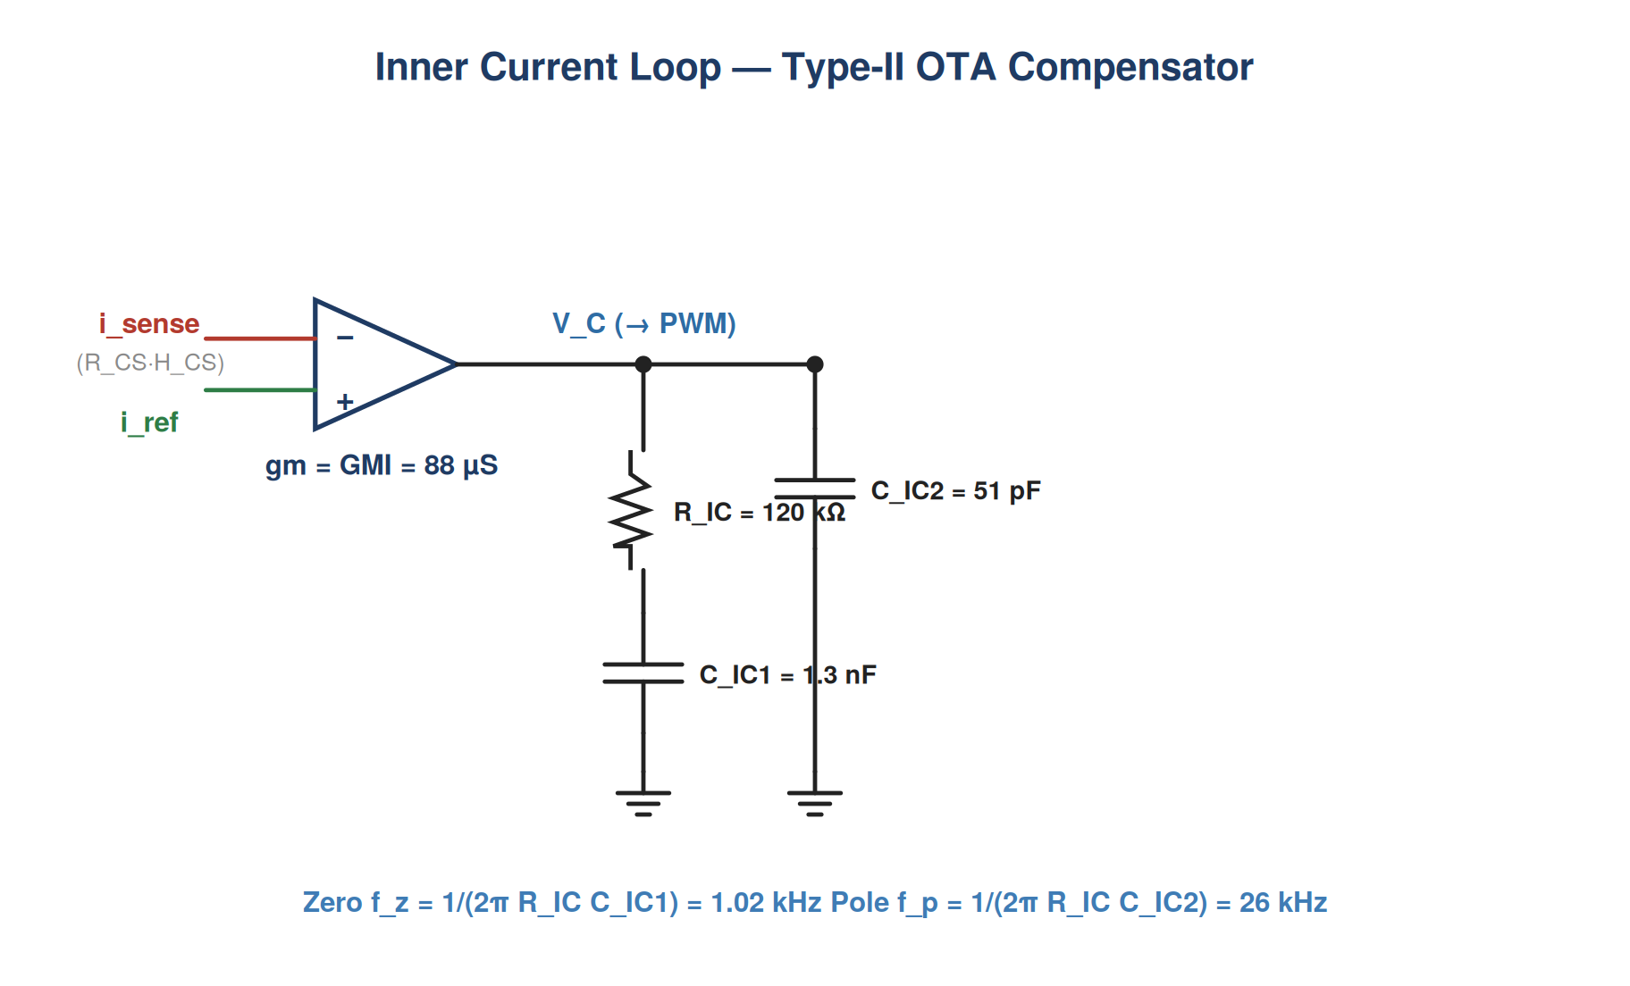
Figure 13A — Type-II network: R_IC = 120 kΩ, C_IC1 = 1.3 nF, C_IC2 = 51 pF. Zero at 1.02 kHz, pole at 26 kHz.
Figure 1 — Open-Loop Current Loop Tᵢ(s) | All 8 Operating Points
The open-loop magnitude and phase are plotted for all eight operating points. Every trace crosses 0 dB at 8.12 kHz with a 62.8° phase margin. Solid traces are low-line (90–132 Vac, 1700 W); dashed traces are high-line (180–264 Vac, 3600 W). Circles mark the 0 dB crossover on each trace.
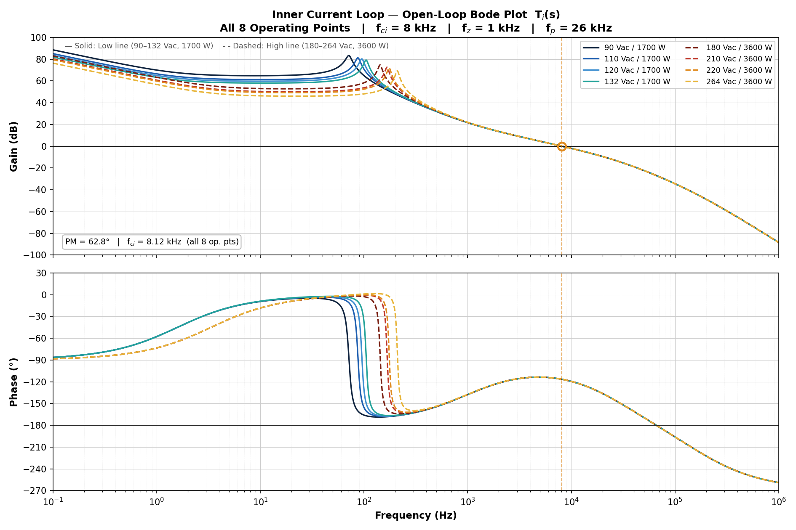
Figure 1 — Open-loop Tᵢ(s): gain (dB, top) and phase (°, bottom). Crossover = 8.12 kHz; phase margin = 62.8°.
Figure 2 — Closed-Loop Current Loop Tᵢ(s)/(1+Tᵢ(s)) | All 8 Operating Points
The closed-loop response shows how the inner current loop tracks its reference. The −3 dB bandwidth is approximately 12 kHz at all operating points, and the traces overlap almost exactly — confirming the design is robust to operating-point variation.
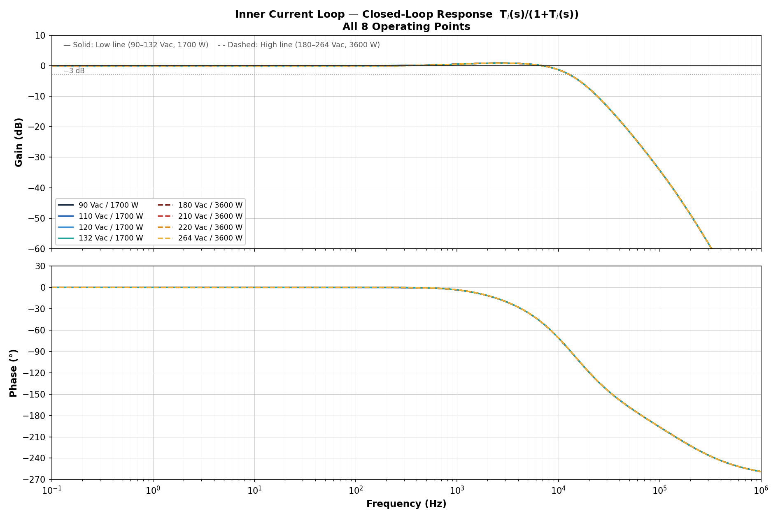
Figure 2 — Closed-loop Tᵢ(s)/(1+Tᵢ(s)): gain and phase. −3 dB bandwidth ≈ 12 kHz.

13.13 Final Summary Table — All 8 Operating Points
The table below consolidates the key parameters and stability metrics for the inner current loop. The phase-margin column is shaded where it exceeds the 45° minimum requirement.
V_AC | P_OUT | D | F₀ (Hz) | Q | f_RHP (kHz) | T_i,unc (dB) | ∠T_i,unc (°) | f_ci (kHz) | PM (°)
90 | 1700 | 0.67671 | 71.59 | 8.653 | 6.454 | −20.010 | −92.66 | 8.12 | 62.8
110 | 1700 | 0.60487 | 87.49 | 10.146 | 9.641 | −20.010 | −92.65 | 8.12 | 62.8
120 | 1700 | 0.56895 | 95.44 | 10.815 | 11.473 | −20.010 | −92.65 | 8.12 | 62.8
132 | 1700 | 0.52584 | 104.97 | 11.550 | 13.883 | −20.010 | −92.65 | 8.12 | 62.8
180 | 3600 | 0.35342 | 143.14 | 12.686 | 12.191 | −20.010 | −92.65 | 8.12 | 62.8
210 | 3600 | 0.24566 | 166.99 | 13.570 | 16.593 | −20.000 | −92.64 | 8.12 | 62.8
220 | 3600 | 0.20974 | 174.94 | 13.795 | 18.211 | −20.000 | −92.64 | 8.12 | 62.8
264 | 3600 | 0.05168 | 209.91 | 14.435 | 26.223 | −20.000 | −92.63 | 8.12 | 62.8
Key findings
- Uncompensated gain: −20.01 dB (±0.01 dB) at 8 kHz across all eight operating points. The loop gain is dominated by the inductive impedance V_OUT/(ω·Lϕ), independent of duty cycle or load.
- Phase margin: 62.8° at every condition — 17.8° above the 45° minimum — giving comfortable margin against component tolerances and parasitics.
- Crossover frequency: 8.12 kHz, ≈1.27× the lowest f_RHP (6.45 kHz at 90 Vac). The phase margin is unaffected because the RHP zero acts in the duty-to-voltage path, not in the current-sensing path.
- Closed-loop bandwidth: ≈12 kHz (−3 dB) — fast enough to track the 100/120 Hz sinusoidal current reference while rejecting switching-frequency noise.
Decision Inner current loop — DESIGN PASS. All 8 operating points: crossover = 8.12 kHz, PM = 62.8°. Proceed to Step 14 — Outer Voltage Loop Design.

Step 14 — Outer Voltage Loop Design
THEORY The outer loop sets the amplitude of the current command to regulate the bus. It must be slow — crossover near 17 Hz — so it does not respond to the 120 Hz ripple inherent on a single-phase-fed bus; responding to that ripple would distort the current reference and wreck the power factor. A Type-III OTA compensator provides the phase boost needed for adequate margin at such a low crossover.
CONCEPT Method B (SLVA662) folds the feedback divider into the OTA compensator network, so the loop gain evaluated here already contains the divider H_v. The closed inner current loop appears in this analysis as a near-unity block, G_i,cl ≈ 1.

14.1 Voltage Loop Architecture — Method B
With the inner current loop closed (Step 13), the outer voltage loop regulates the DC bus by commanding the current reference. The voltage-loop gain is the product of the gain-modulator term, the closed current loop, and the voltage plant. Following the OTA Type-III approach of SLVA662 (Method B), the feedback divider H_v = V_FBPFC / V_OUT is moved out of the plant and absorbed into the compensator transfer function from V_O to V_EA, so the loop gain evaluated here excludes both the divider and the compensator:
$T_{v,base}(s) = \frac{K_{MAX} × I_{OUT}}{V_{RAMP}} × G_{i,cl}(s) × G_{vp}(s)$
where the three factors are the multiplier gain term, the current-loop closed-loop transfer function, and the accurate voltage plant:
$G_{MOD} = \frac{K_{MAX} × I_{OUT}}{V_{RAMP}} G_{i,cl}(s) = \frac{\frac{T_{i}(s)}{N_{CH}}}{1 + \frac{T_{i}(s)}{N_{CH}}}$
$G_{vp}(s) = \frac{(1 + sC_{O}r_{C})(1 − s/ω_{RHP})}{C_{O} s + 2/R_{LOAD}}$
The feedback divider, moved into the OTA Type-III compensator (Method B), is:
$H_{v} = \frac{V_{FBPFC}}{V_{OUT}} = \frac{2.5}{393.7} = 0.006350$
Parameter | Value | Source / Role
Max multiplier gain K_MAX | 1.49 | Step 6 selection (149%)
Output voltage V_OUT | 393.7 V | Regulated DC bus
Feedback reference V_FBPFC | 2.5 V | FBPFC regulation point
Ramp voltage V_RAMP | 5 V | Internal PWM ramp
Output capacitor C_O | 2 200 µF | Bus capacitor
Capacitor ESR r_C | 10 mΩ | Output-cap ESR
Channels N_CH | 2 | Interleaved phases
Effective inductance L_eq = L/2 | 117.5 µH | Two-phase combined plant
Transconductance GMV | 100 µS | Voltage-loop OTA
Voltage-loop crossover f_cv | 17 Hz | Design target

14.2 Voltage Plant RHP Zero — All 8 Operating Points
The interleaved boost plant presents a right-half-plane zero whose frequency depends on the load and duty complement. The two-phase combined plant uses the effective inductance L_eq = L/2 = 117.5 µH:
$D' = \frac{\sqrt{2} × V_{AC}}{V_{OUT}} ω_{RHP} = \frac{R_{LOAD} × {(D')}^{2}}{L_{eq}} f_{RHP} = \frac{ω_{RHP}}{2π}$
V_AC (V) | P_OUT (W) | R_LOAD (Ω) | D' | f_RHP (kHz)
90 | 1700 | 91.1763 | 0.3233 | 12.91
110 | 1700 | 91.1763 | 0.3951 | 19.28
120 | 1700 | 91.1763 | 0.4310 | 22.95
132 | 1700 | 91.1763 | 0.4741 | 27.77
180 | 3600 | 43.0555 | 0.6466 | 24.38
210 | 3600 | 43.0555 | 0.7543 | 33.19
220 | 3600 | 43.0555 | 0.7903 | 36.42
264 | 3600 | 43.0555 | 0.9483 | 52.45
Note The voltage-plant RHP-zero frequency is twice the corresponding current-loop value (Step 13) because the combined two-phase plant uses L_eq = L/2 = 117.5 µH rather than the per-phase 235 µH. Even the lowest f_RHP (12.91 kHz) is far above the 17 Hz crossover, so the RHP zero has negligible effect on voltage-loop phase margin.

14.3 Detailed Calculation — 180 Vac / 3600 W (design point)
The compensator is sized at the 3600 W high-line design point, where the loop must cross over at 17 Hz at full power. All quantities are evaluated at f_cv = 17 Hz, s = j·2π·17 = j106.81 rad/s.
Step 1 Load resistance and output current:
$R_{LOAD} = \frac{V_{OUT}^{2}}{P_{OUT}} = \frac{{393.7}^{2}}{3600} = 43.0555 Ω$
$I_{OUT} = \frac{P_{OUT}}{V_{OUT}} = \frac{3600}{393.7} = 9.1440 A$

Step 2 Multiplier gain term:
$G_{MOD} = \frac{K_{MAX} × I_{OUT}}{V_{RAMP}} = \frac{1.49 × 9.1440}{5} = 2.7249$

Step 3 Duty complement and RHP zero:
$D' = \frac{\sqrt{2} × 180}{393.7} = 0.6466$
$ω_{RHP} = \frac{43.0555 × {0.6466}^{2}}{117.5 µH} = 153 191 rad/s$
$f_{RHP} = 24.38 kHz$

Step 4 Current-loop closed-loop term at 17 Hz:
Using the full inner current loop with its Type-2 OTA compensator (Step 13):
$T_{i}(j2π·17) = 425.96 − j81.32 \left|T_{i}\right| = 433.65 ∠T_{i} = −10.81°$
$G_{i,cl}(j2π·17) = \frac{T_{i}/2}{1 + T_{i}/2} = 0.995490 − j0.000857$
$\left|G_{i,cl}\right| = 0.99549 ∠G_{i,cl} = −0.0493°$
At 17 Hz the current loop is essentially unity (its bandwidth is 8.12 kHz), but it is retained for accuracy.

Step 5 Voltage plant at 17 Hz:
$G_{vp}(j2π·17) = 0.81633 − j4.09412$
$\left|G_{vp}\right| = 4.17471 ∠G_{vp} = −78.72°$

Step 6 Voltage-loop gain without compensator:
$T_{v,base} = G_{MOD} × G_{i,cl} × G_{vp} = 2.7249 × 0.99549 × 4.17471$
$\left|T_{v,base}\right| = 11.3244 (21.08 dB)$
Including the feedback divider H_v (shown here for reference; in Method B it is part of the compensator):
$\left|T_{v}\right| = \left|T_{v,base}\right| × H_{v} = 11.3244 × 0.006350 = 0.07191$
$\left|T_{v}\right| = 0.07191 (−22.86 dB) ∠T_{v} = −78.77°$

14.4 Voltage Loop Gain Without Compensator — All 8 Operating Points
|T_v| is the loop gain including the divider but without the compensator; |T_v,base| (Method B, divider in compensator) is |T_v| / H_v and sets the required compensator gain.
V_AC (V) | P_OUT (W) | f_RHP (kHz) | |G_vp| | |T_v,base| | |T_v| (dB) | ∠T_v (°)
90 | 1700 | 12.91 | 4.2371 | 5.4461 | −29.22 | −84.61
110 | 1700 | 19.28 | 4.2371 | 5.4429 | −29.23 | −84.59
120 | 1700 | 22.95 | 4.2371 | 5.4411 | −29.23 | −84.59
132 | 1700 | 27.77 | 4.2371 | 5.4387 | −29.23 | −84.58
180 | 3600 | 24.38 | 4.1747 | 11.3244 | −22.86 | −78.77
210 | 3600 | 33.19 | 4.1747 | 11.3057 | −22.88 | −78.78
220 | 3600 | 36.42 | 4.1747 | 11.2989 | −22.88 | −78.78
264 | 3600 | 52.45 | 4.1747 | 11.2651 | −22.91 | −78.81

14.5 Required Compensator Gain
To force the loop to cross 0 dB at f_cv = 17 Hz, the OTA Type-III compensator (which now contains the divider H_v) must supply a magnitude equal to the inverse of the uncompensated base gain:
$\left|H_{OTA}\right|(17 Hz) = \frac{1}{\left|T_{v,base}\right|}$
Sizing at the high-line 3600 W design point:
$\left|H_{OTA}\right| = \frac{1}{11.3244} = 0.088305 (−21.08 dB)$
At low line (1700 W) the base gain is lower (|T_v,base| ≈ 5.45), so the same compensator yields a lower crossover — quantified in Section 14.9.

14.6 OTA Type-III Compensator Design (SLVA662, Method B)
The compensator is an OTA Type-III network. Method B includes the feedback divider resistors R1 = R_FB,top and R4 = R_FB,bottom inside the compensator together with gm, R2, R3, C1, C2 and C3. Its transfer function and pole-zero targets are:
$H_{OTA}(s) = −G_{0} × \frac{(1 + ω_{z1}/s)(1 + s/ω_{z2})}{(1 + s/ω_{p1})(1 + s/ω_{p2})}$
Quantity | Value | Symbol | Role
Top feedback resistor | 3.63 MΩ | R1 = R_FB,top | From Step 5 divider
Bottom feedback resistor | 23.2 kΩ | R4 = R_FB,bottom | From Step 5 divider
Transconductance | 100 µS | gm = GMV | Voltage-loop OTA
Crossover | 17 Hz | f_c | Design target
Required gain at f_c | 0.088305 | G | = 1/|T_v,base| (HL)
Zero 1 / Zero 2 | 3 Hz / 12 Hz | f_z1 / f_z2 | Phase boost
Pole 1 / Pole 2 | 50 Hz / 17 Hz | f_p1 / f_p2 | HF roll-off
Intermediate SLVA662 factors
$a = \sqrt{1 + (^{}\frac{f_{c}}{f_{p2}})^{2}} = \sqrt{1 + {(17/17)}^{2}} = 1.4142$
$b = \sqrt{1 + {(17/50)}^{2}} = 1.0562$
$c = \sqrt{1 + {(3/17)}^{2}} = 1.0155$
$d = \sqrt{1 + {(17/12)}^{2}} = 1.7341$
$aa = \frac{a × b}{c × d} = \frac{1.4142 × 1.0562}{1.0155 × 1.7341} = 0.8483$

Component values (design point)
Step 1 Gain factor bb and R2:
$bb = \frac{G × f_{p2} (R1 + R4)}{R4 × gm (f_{p2} − f_{z1})} = \frac{0.088305 × 17 × 3.6532 MΩ}{23.2k × 100µS × 14} = 168.85 kΩ$
$R2 = aa × bb = 0.8483 × 168.85k = 143.23 kΩ$

Step 2 R3 and C2 (second branch — sets f_z2 and f_p2):
R3 and C2 satisfy f_z2 = 1/[2π(R1+R3)C2] and f_p2 = 1/[2π(R3+R1∥R4)C2] simultaneously with R1 = 3.63 MΩ, R4 = 23.2 kΩ:
$R3 = 8.6336 MΩ C2 = 1.0815 nF$

Step 3 C1 (sets f_z1):
$C1 = \frac{1}{2π × f_{z1} × R2} = \frac{1}{2π × 3 × 143.23k} = 370.39 nF$

Step 4 C3 (sets f_p1 with R2, C1):
$C3 = \frac{C1}{2π × C1 × R2 × f_{p1} − 1} = 23.64 nF$

14.7 Final Compensator Component Values
Component | Calculated | Standard value | Sets
R2 | 143.23 kΩ | 143 kΩ | f_z1, f_p1
R3 | 8.6336 MΩ | 8.66 MΩ | f_z2, f_p2
C1 | 370.39 nF | 390 nF | f_z1
C2 | 1.0815 nF | 1.1 nF | f_z2
C3 | 23.64 nF | 24 nF | f_p1
Decision Voltage compensator (OTA Type-III, GMV = 100 µS): R2 = 143 kΩ, R3 = 8.66 MΩ, C1 = 390 nF, C2 = 1.1 nF, C3 = 24 nF, with divider R1 = 3.63 MΩ / R4 = 23.2 kΩ. Pole-zero set: f_z1 = 3 Hz, f_z2 = 12 Hz, f_p1 = 50 Hz, f_p2 = 17 Hz.

14.8 Pole-Zero Verification (calculated values)
$f_{z1} = \frac{1}{2π R2 C1} = 3.000 Hz$
$f_{z2} = \frac{1}{2π (R1 + R3) C2} = 12.000 Hz$
$f_{p1} = \frac{C1 + C3}{2π R2 C1 C3} = 50.000 Hz$
$f_{p2} = \frac{1}{2π (R3 + R1∥R4) C2} = 17.000 Hz$

14.9 Voltage-Loop Crossover and Stability — All 8 Operating Points
With the final standard components the loop is evaluated across all operating points. Because the compensator is sized for the 3600 W design point, the high-line crossover is 17 Hz; at low line (1700 W) the lower plant gain shifts the crossover down to about 7.8 Hz. Phase margin is high (~81–82°) at every condition.
V_AC (V) | P_OUT (W) | Loop gain at 17 Hz (dB) | Crossover f_cv (Hz) | Phase margin (°)
90 | 1700 | −6.36 | 7.80 | 80.9
110 | 1700 | −6.36 | 7.80 | 80.9
120 | 1700 | −6.36 | 7.80 | 80.9
132 | 1700 | −6.37 | 7.79 | 80.9
180 | 3600 | 0.00 | 17.00 | 82.4
210 | 3600 | −0.01 | 16.97 | 82.4
220 | 3600 | −0.02 | 16.96 | 82.4
264 | 3600 | −0.04 | 16.91 | 82.4
Note The voltage loop is unconditionally stable across the universal-input range: phase margin stays near 81–82° and the gain margin is large because the loop has rolled well below 0 dB long before the phase reaches −180°. The 1700 W crossover of 7.8 Hz is expected — the compensator is sized at the 3600 W full-power design point.
Figure 14A — Type-III OTA Voltage-Loop Compensator Schematic
The voltage OTA (GMV = 100 µS) senses the bus through the R1/R4 divider and drives the Type-III network. R2-C1 set the first zero and the integrator, C3 adds the first high-frequency pole, and the R3-C2 branch provides the second zero/pole pair (Method B folds the divider into the compensator).
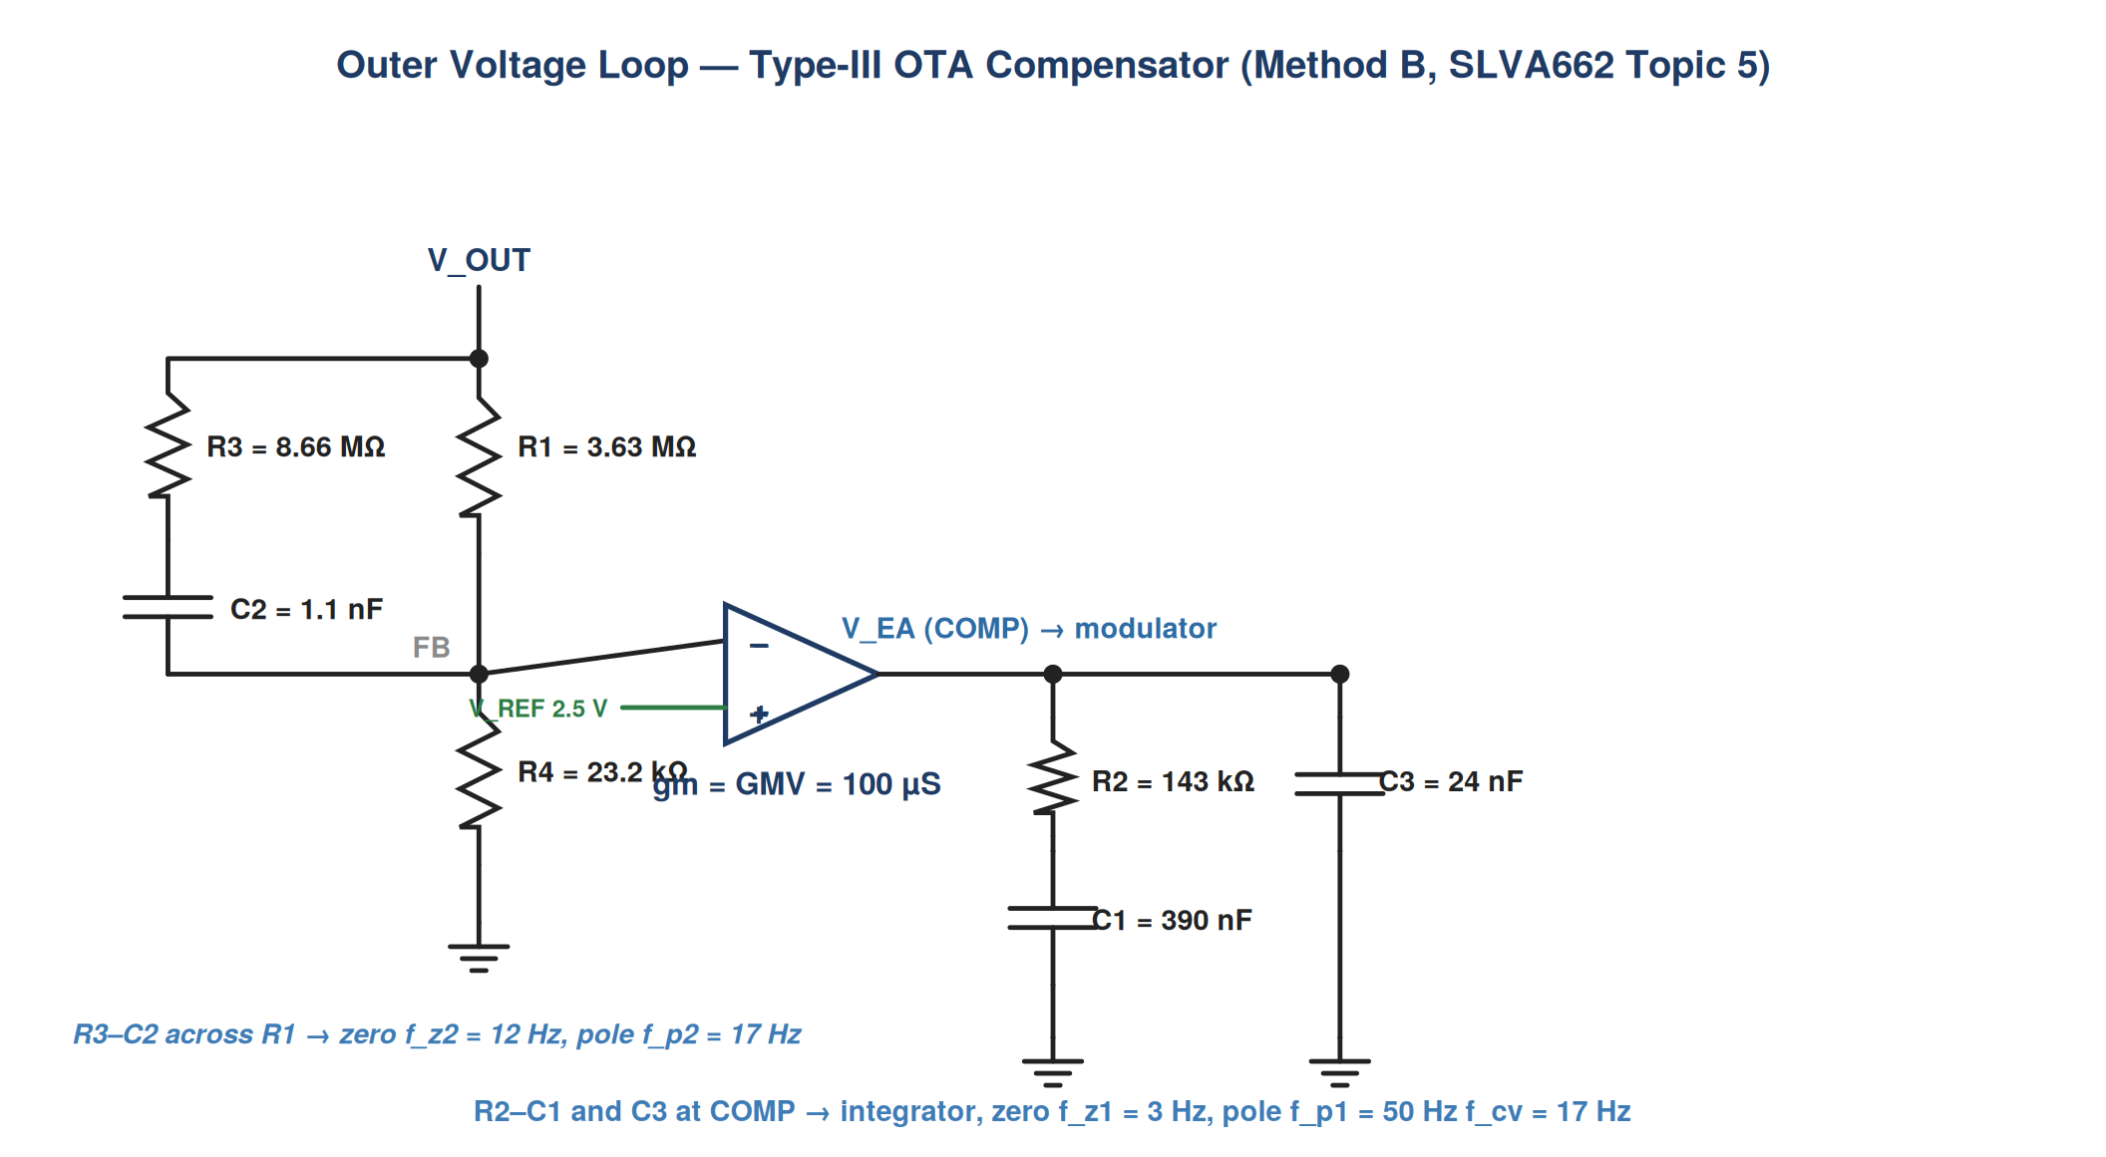
Figure 14A — Type-III network: R2 = 143 kΩ, R3 = 8.66 MΩ, C1 = 390 nF, C2 = 1.1 nF, C3 = 24 nF. Zeros 3/12 Hz, poles (origin) 50/17 Hz.
Figure 3 — Open-Loop Voltage Loop Tᵥ(s) | All 8 Operating Points
The open-loop voltage gain crosses 0 dB at 7.8 Hz (low line, solid) and 17 Hz (high line, dashed). The Type-III compensator lifts the phase near crossover, giving ≈81–82° phase margin. Vertical markers indicate the two crossover frequencies.
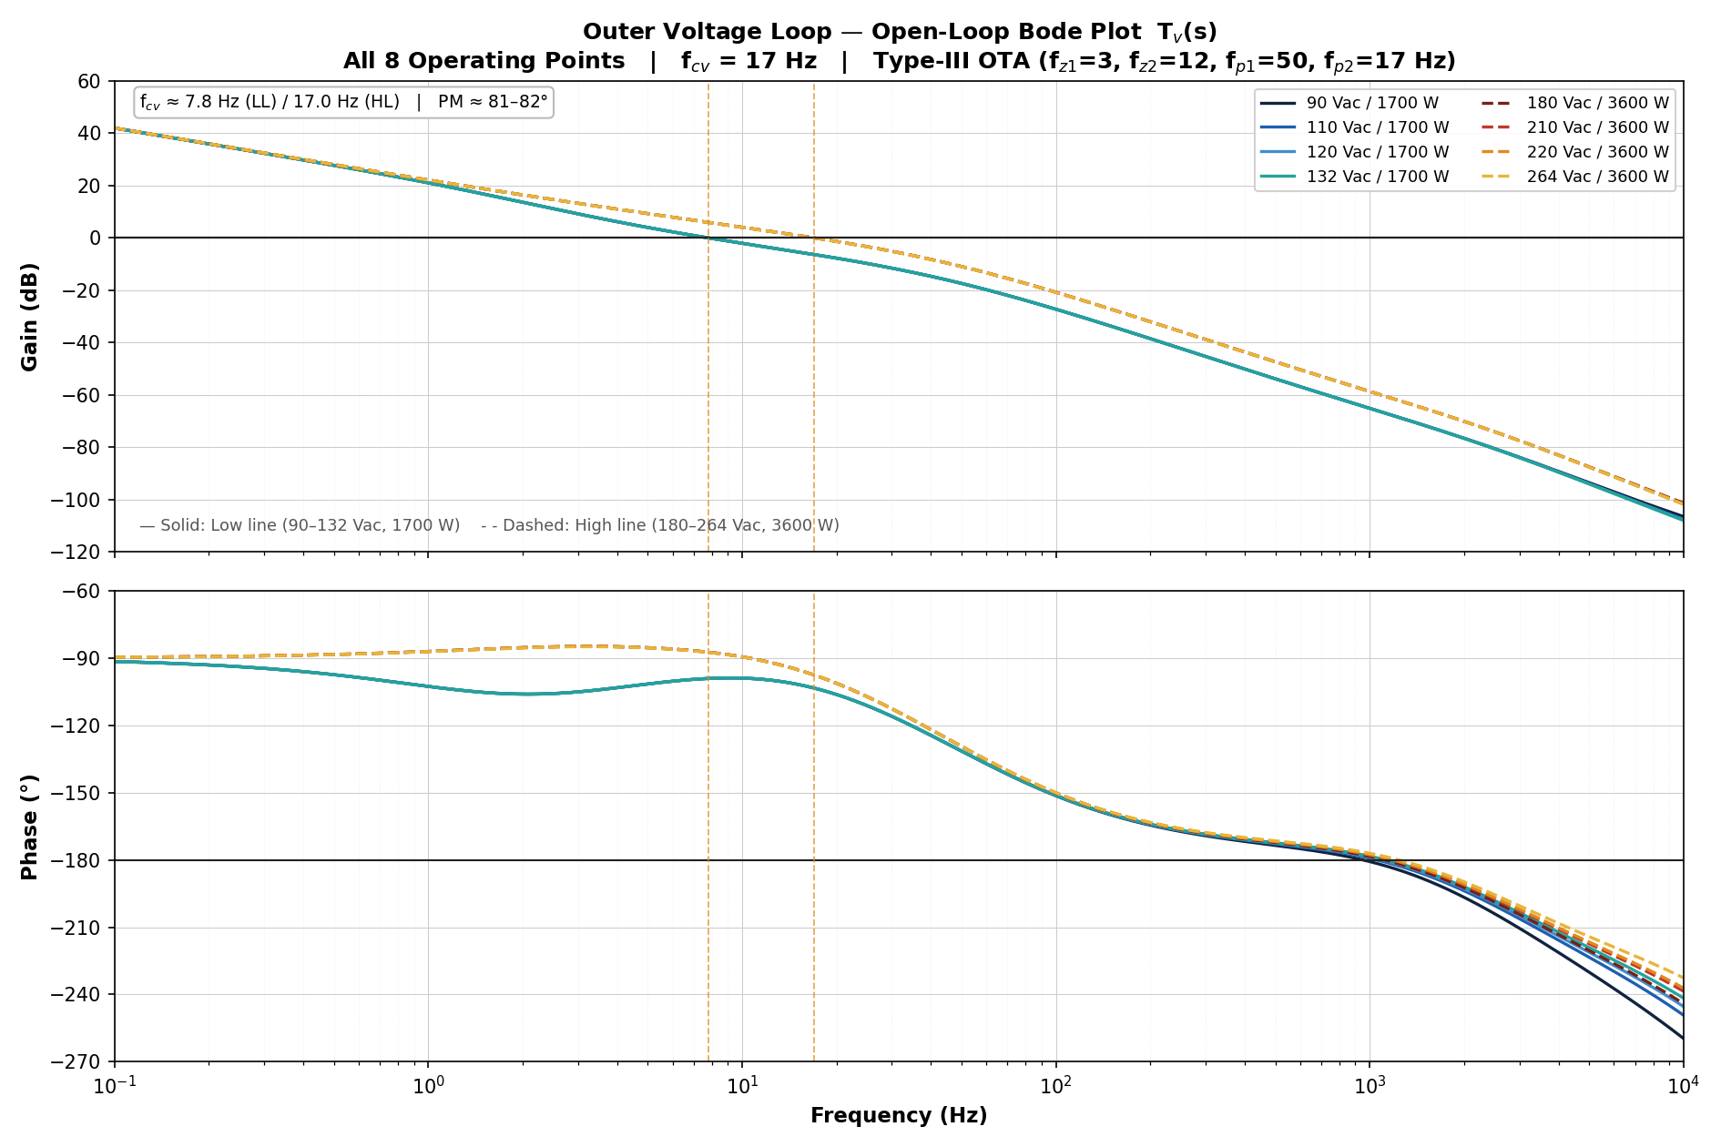
Figure 3 — Open-loop Tᵥ(s): gain (dB, top) and phase (°, bottom). Crossover 7.8 Hz (LL) / 17 Hz (HL); PM ≈ 81–82°.
Figure 4 — Closed-Loop Voltage Loop Tᵥ(s)/(1+Tᵥ(s)) | All 8 Operating Points
The closed-loop voltage response is flat to the loop bandwidth and rolls off smoothly with no peaking, confirming the high phase margin and well-damped regulation at every operating point.
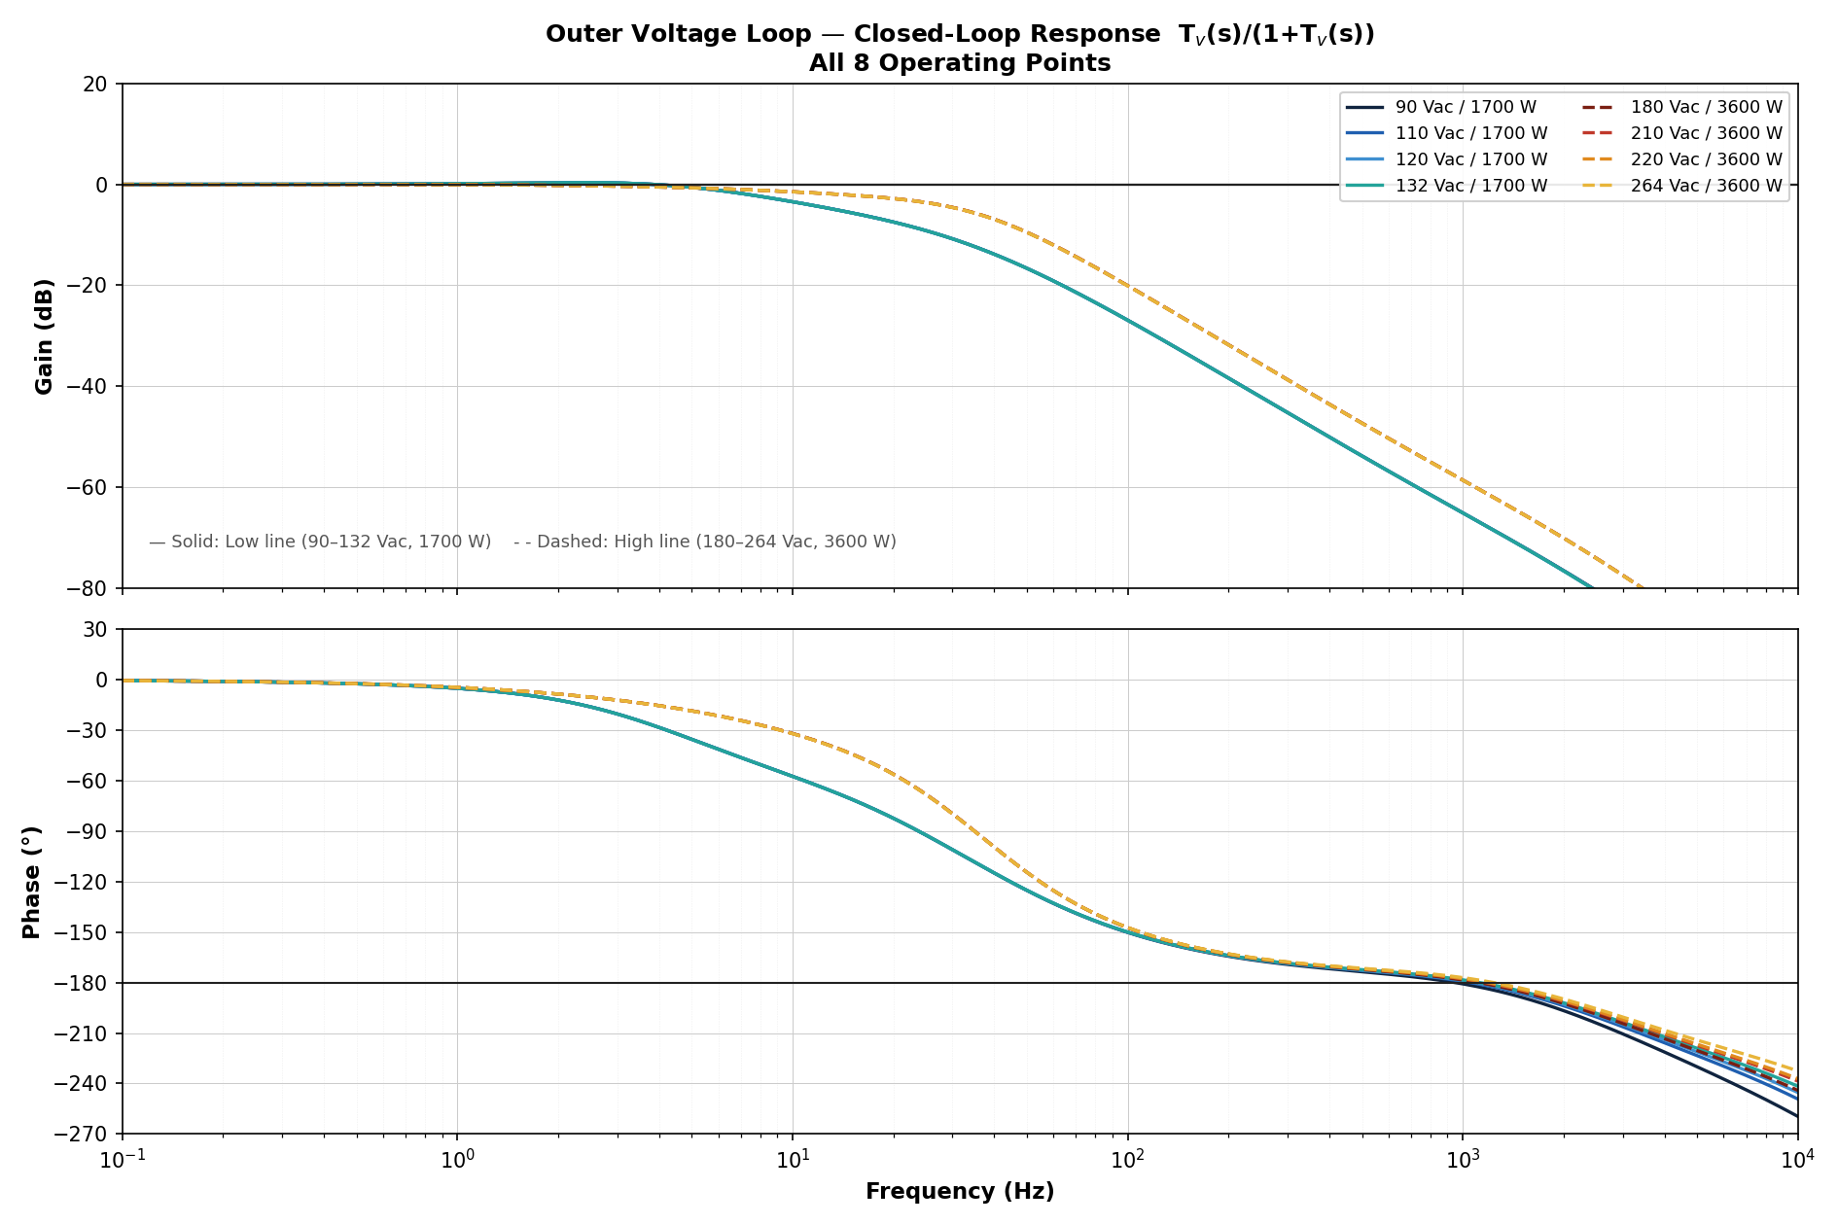
Figure 4 — Closed-loop Tᵥ(s)/(1+Tᵥ(s)): gain and phase across all 8 operating points.
Decision Outer voltage loop — DESIGN PASS. Crossover 17 Hz at 3600 W (PM 82°) and 7.8 Hz at 1700 W (PM 81°). Compensator: R2 = 143 kΩ, R3 = 8.66 MΩ, C1 = 390 nF, C2 = 1.1 nF, C3 = 24 nF (OTA Type-III, GMV = 100 µS).

Step 15 — Step Load Transient Response
CONCEPT A load step is rejected through the closed-loop output impedance Z_cl(s) = Z_open(s)/(1+T_v(s)). Because the compensator integrates, Z_cl is zero at DC — so the bus always recovers fully; the only questions are how far it dips and how long it takes.
INSIGHT The transient dip is the unavoidable price of the slow voltage loop chosen in Step 14. With the power components fixed, the dip can only be traded against 120 Hz rejection (THD) — which is exactly what Step 17 quantifies.

15.1 Method — Closed-Loop Output Impedance
A load-current step is rejected by the closed voltage loop. The output-voltage deviation is the load step acting through the closed-loop output impedance, which is the open-loop output impedance divided by the return difference (1 + T_v). Because the compensator contains an integrator, the closed-loop output impedance is zero at DC, so the deviation always recovers fully to the regulation point.
${ΔV}_{OUT}(s) = −{ΔI}_{LOAD}(s) × \frac{Z_{open}(s)}{1 + T_{v}(s)}$
The open-loop output impedance is set by the bus capacitor working into the boost small-signal load term (the same denominator as the voltage plant); the ESR adds a small instantaneous step:
$Z_{open}(s) = \frac{1 + sC_{O}r_{C}}{C_{O} s + 2/R_{LOAD}}$
For a load step of magnitude ΔI the time response ΔVout(t) is obtained from the inverse transform. The peak deviation occurs near the loop bandwidth and the deviation then recovers; recovery time is measured to the ±1% band (±3.94 V about the 393.7 V bus). The peak scales linearly with step size, and at this small-signal level step-up and step-down are symmetric.
Quantity | Value | Note
Bus capacitor C_O | 2 200 µF | Fixed (power stage)
Recovery band | ±1% = ±3.94 V | About 393.7 V bus
Voltage-loop crossover f_cv | 7.8 Hz (LL) / 17 Hz (HL) | Step 14 design
Full-load current I_full = P_OUT/V_OUT | 4.318 A (1700 W) / 9.144 A (3600 W) | Step magnitude reference

15.2 Step Magnitudes
Six load transitions are evaluated — three load-increase (dip) and three load-decrease (overshoot) — at both line ranges. The current step ΔI for each transition:
Load transition | ΔI (Low line, 1700 W) | ΔI (High line, 3600 W)
0 → 100% (full step up) | +4.318 A | +9.144 A
0 → 50% | +2.159 A | +4.572 A
50 → 100% | +2.159 A | +4.572 A
100 → 0% (full step down) | −4.318 A | −9.144 A
50 → 0% | −2.159 A | −4.572 A
100 → 50% | −2.159 A | −4.572 A

15.3 Results — Peak Deviation and Recovery Time
Peak deviation and recovery time to the ±1% band, computed for our design. Values are identical across the four voltages within each line range (the load resistance and loop shape depend on power, not on line voltage):
Load transition | LL ΔV (V) | LL % | LL t_rec | HL ΔV (V) | HL % | HL t_rec
0 → 100% | −25.9 | −6.6% | 154 ms | −28.9 | −7.3% | 152 ms
0 → 50% | −13.0 | −3.3% | 122 ms | −14.5 | −3.7% | 112 ms
50 → 100% | −13.0 | −3.3% | 122 ms | −14.5 | −3.7% | 112 ms
100 → 0% | +25.9 | +6.6% | 154 ms | +28.9 | +7.3% | 152 ms
50 → 0% | +13.0 | +3.3% | 122 ms | +14.5 | +3.7% | 112 ms
100 → 50% | +13.0 | +3.3% | 122 ms | +14.5 | +3.7% | 112 ms
Note The worst-case transient is the full 0→100% step at high line: a 28.9 V (7.3%) dip recovering in 152 ms. This is expected for a PFC whose voltage loop is intentionally slow (17 Hz) to reject the 120 Hz bus ripple. If the application requires a smaller dip, the bus capacitor must be increased or the loop bandwidth raised — the latter at the cost of 120 Hz rejection / THD, as quantified in Step 17.
Figure 5 — Step Load Transient Response | All 6 Transitions, Low Line vs High Line
Closed-loop output-voltage deviation for each load transition. Blue = low line (90 Vac/1700 W), red = high line (180 Vac/3600 W). The shaded band is the ±1% recovery window. Load-increase steps (top row) dip; load-decrease steps (bottom row) overshoot.
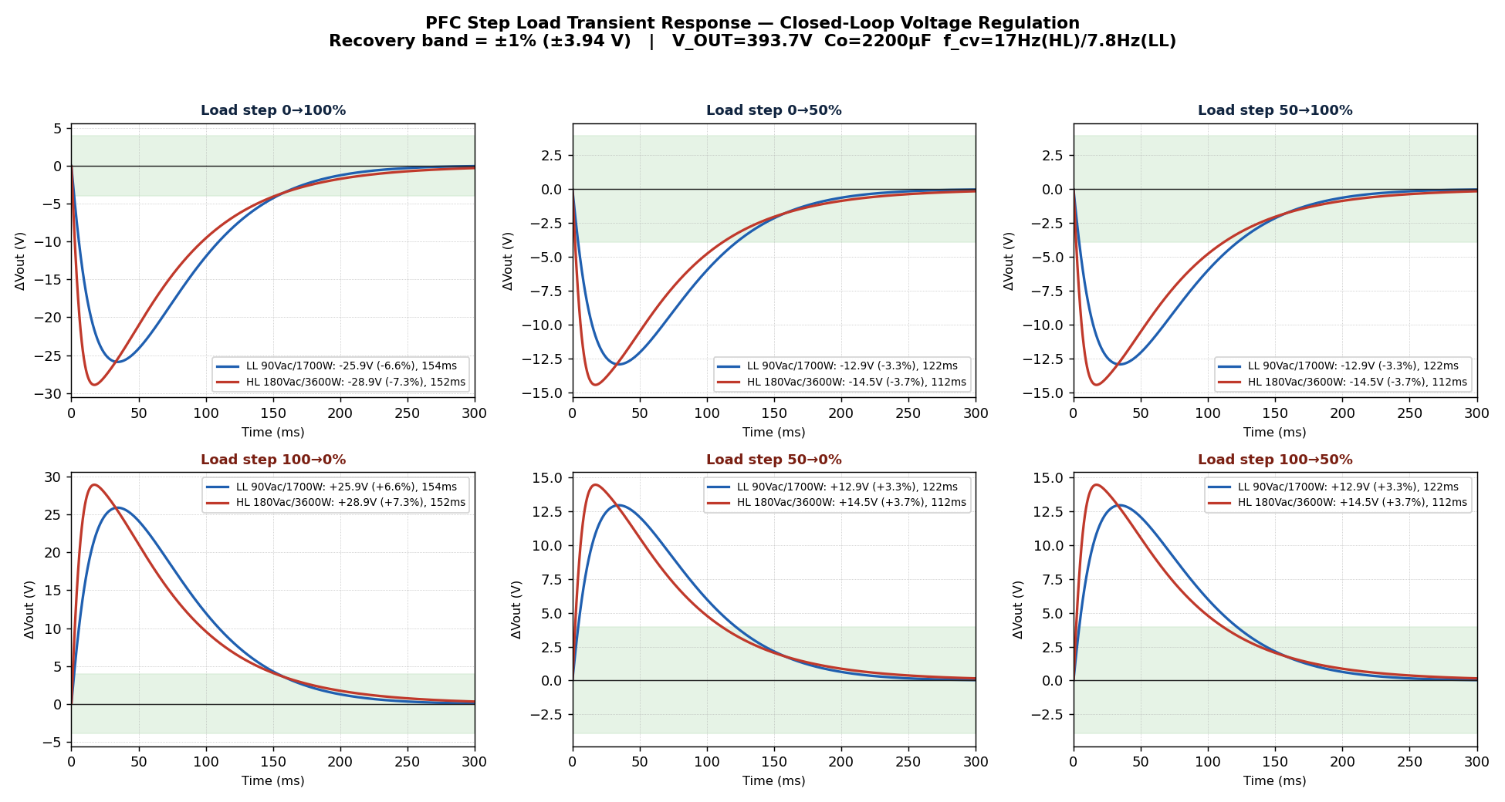
Figure 5 — ΔVout vs time for the six load transitions. Worst case: HL 0→100% = −28.9 V (−7.3%), recovering in 152 ms.
Decision Step load transient — worst-case dip 28.9 V (7.3%) at HL 0→100%, full recovery within 152 ms; low-line worst case 25.9 V (6.6%) in 154 ms. All transitions recover monotonically with no ringing (phase margin > 80°).

Step 16 — Input Current THD and 120 Hz Rejection
THEORY Input-current distortion from the control loop is set by how strongly the loop rejects the 120 Hz bus ripple. Any loop gain at 120 Hz modulates the current command at twice the line frequency, injecting a third harmonic into the input current. A low voltage-loop crossover is what keeps this contribution small.
ON THE BENCH Measure this with a precision power analyzer (e.g. Yokogawa WT-series) reading input-current THD directly, and separately capture the bus 120 Hz ripple with an AC-coupled scope probe. Correlate the measured THD trend across line/load with the rejection figures in this step.

16.1 Mechanism — Why 120 Hz Rejection Sets THD
In a PFC the bus carries a twice-line-frequency (120 Hz at 60 Hz line) ripple. The voltage loop senses this ripple through the FBPFC divider. Any loop gain at 120 Hz modulates the current-command reference at 120 Hz, which mixes with the rectified-sine reference to inject a 3rd-harmonic distortion into the input current. The dominant control-loop contribution to input-current THD is therefore set by how strongly the loop attenuates 120 Hz — the 120 Hz rejection. A deliberately slow voltage loop (17 Hz crossover, far below 120 Hz) is what keeps this contribution small.
The peak 120 Hz bus ripple from the delivered power is:
$V_{ripple}^{},pk = \frac{P_{OUT}}{2 × ω_{line} × V_{OUT} × C_{O}}$
The 120 Hz rejection is the inverse of the open-loop gain at 120 Hz:
$Rejection (dB) = − 20 log₁₀\left|T_{v}(j2π·120)\right|$
The residual 120 Hz on the error-amplifier output, and the resulting 2nd-harmonic-feedback THD contribution (a 120 Hz modulation of the reference produces a 3rd line harmonic of roughly half its relative depth):
$V_{EA,120} = \frac{\left|H_{OTA}(j2π·120)\right| × V_{ripple}^{},pk}{\left|1 + T_{v}(j2π·120)\right|}$
${THD}_{3} ≈ 50 × \frac{V_{EA,120}}{V_{EA}} \%$

16.2 Results — 120 Hz Rejection and THD Contribution
Computed for the baseline design (f_cv = 17 Hz). The bus ripple and rejection depend on power level, so values are grouped by line range:
Operating range | V_ripple,pk (120 Hz) | Ripple % | 120 Hz Rejection | THD₃ contribution
Low line 90–132 Vac / 1700 W | 2.60 V | 0.66% | 30.0 dB | ≈ 1.45%
High line 180–264 Vac / 3600 W | 5.51 V | 1.40% | 23.5 dB | ≈ 2.99%
Note These are the control-loop (2nd-harmonic-feedback) contribution to input-current THD — the dominant loop-related term and the one the compensator controls. Total measured converter THD also includes current-loop tracking error, cusp/cross-over distortion near the line zero-crossing, and EMI-filter effects, which are not part of the small-signal loop model. High line is the worst case (23.5 dB rejection, ~3% THD₃ contribution) because both the bus ripple and the loop gain at 120 Hz are larger at full power.
Figure 6 — 120 Hz Rejection and Closed-Loop Attenuation
Left: closed-loop voltage response showing strong attenuation by 120 Hz at every operating point. Right: 120 Hz rejection per operating point — 30 dB at low line, 23.5 dB at high line, all above the 20 dB minimum.
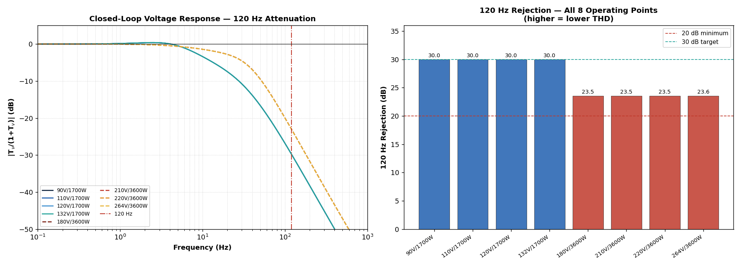
Figure 6 — 120 Hz rejection: 30 dB (low line) and 23.5 dB (high line), comfortably above the 20 dB minimum for low THD.
Decision Input-current THD — 120 Hz rejection is 30 dB (low line) and 23.5 dB (high line), giving an estimated 2nd-harmonic-feedback THD contribution of ~1.5% and ~3% respectively. Both exceed the 20 dB minimum. To reduce THD further, lower the voltage-loop crossover (see Step 17, Design A) at the cost of a larger load-transient dip.

Step 17 — Loop Equation Accuracy and Compensator Optimization
INSIGHT With the power stage frozen, the only remaining design freedom is the compensator pole/zero placement. Every performance axis — transient dip, 120 Hz rejection / THD, phase margin — trades against the others through a single knob: the voltage-loop crossover. This step makes that trade-off explicit and quantifies four operating points along it.
PITFALL Designing from the simplified textbook equations (constant −90° plant, lossless inductor) leaves margin on the table and can mislead the compensator choice. The accurate equations used throughout this report reveal about 11° more voltage-loop phase margin — margin that is real and usable.

17.1 Equation Accuracy — Simplified vs Accurate
The control loops in this report were designed with the accurate small-signal equations rather than the textbook simplifications. Two refinements matter. First, the current-loop plant G_id: the simple form V_OUT/(L·s) assumes a lossless inductor and gives an infinite-Q resonance, whereas the accurate equation (AND9925 eq.14) includes the inductor resistance r_L, which damps the resonance to a finite Q. With r_L = 10 mΩ our Q ranges from 8.7 (90 Vac) to 14.4 (264 Vac); ignoring r_L would predict a wildly higher Q and a false picture of the current-loop peaking.
Second, the voltage-loop plant: the simplified model treats the output as a pure capacitor 1/(s·C_O) with a constant −90° phase. The accurate plant adds the boost right-half-plane zero, the capacitor-ESR zero and the load pole, which together give about −84.6° at the 17 Hz crossover — roughly 5° less phase lag than the simplified model. The accurate equation therefore predicts a higher phase margin; the simplified model is conservative (it under-reports margin) and can lead to over-compensation.
Aspect | Simplified equation | Accurate equation (used here)
Current-loop plant G_id | V_OUT/(L·s), Q → ∞ (undamped) | AND9925 eq.14 with r_L — finite Q = 8.7–14.4
Resonance damping | none (peak unbounded) | r_L sets Q; peak bounded and realistic
Voltage-plant phase @ 17 Hz | −90.0° (pure integrator) | −84.6° (RHP zero + ESR + load pole)
Voltage-loop phase margin | 68.8° | 80.0° (+11° more margin)
120 Hz rejection | 23.5 dB (HL) | 23.5 dB (HL) — essentially unchanged
Figure 7 — Simplified vs Accurate Equation Comparison
Top: current-loop plant — the simple V_OUT/(L·s) form (dashed) has a fixed −90° phase and no resonance, while the accurate eq.14 (solid) shows the r_L-damped resonance. Bottom: voltage-loop gain and phase — the accurate plant (solid) has less phase lag at crossover than the simplified 1/(sC_O) model (dashed), giving more phase margin (80° vs 69°).
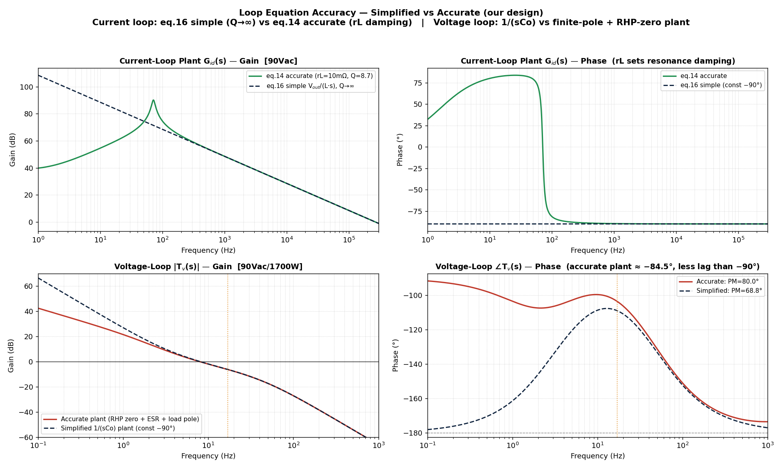
Figure 7 — The accurate equations (used throughout this report) reveal ~11° more voltage-loop phase margin than the simplified model and correctly bound the current-loop resonance.

17.2 Compensator Optimization — Transient vs 120 Hz Rejection / THD
The power components (C_O = 2200 µF, L = 235 µH) are fixed and cannot be changed; only the compensator pole/zero placement is free. Lowering the voltage-loop crossover improves 120 Hz rejection (lower THD) but enlarges and slows the load-transient response; raising it does the opposite. Four designs spanning this trade-off were evaluated by scaling the Type-III pole/zero pattern to different crossover frequencies and re-sizing the gain:
Design | f_cv (HL) | PM_v (LL / HL) | 120 Hz Rej (LL / HL) | 0→100% dip (LL / HL) | Recovery (LL/HL)
Baseline | 17 Hz | 80° / 82° | 30.0 / 23.5 dB | −25.9 / −28.9 V | 154 / 152 ms
A — THD / rejection focus | 12 Hz | 85° / 87° | 35.5 / 29.1 dB | −34.2 / −38.1 V | 238 / 242 ms
B — Balanced | 20 Hz | 78° / 81° | 27.5 / 21.0 dB | −22.3 / −25.1 V | 118 / 114 ms
C — Transient focus | 25 Hz | 76° / 79° | 24.1 / 17.7 dB | −18.3 / −20.6 V | 88 / 82 ms
The corresponding compensator values (R3 ≈ 8.66 MΩ and C2 ≈ 1.1 nF stay essentially fixed; only R2, C1 and C3 scale with crossover):
Design | R2 | C1 | C3 | Effect
Baseline (17 Hz) | 143 kΩ | 390 nF | 24 nF | Reference — balanced
A (12 Hz) | 103 kΩ | 750 nF | 47 nF | Best THD, worst transient
B (20 Hz) | 168 kΩ | 270 nF | 18 nF | Faster transient, rejection OK
C (25 Hz) | 209 kΩ | 180 nF | 11 nF | Fastest transient, THD risk
Figure 8 — Compensator Optimization Trade-off (power components fixed)
Open-loop gain, load-step transient (dip and overshoot) and 120 Hz rejection for the four designs at high line. Design A (12 Hz) maximises 120 Hz rejection but gives the largest, slowest transient; Design C (25 Hz) gives the fastest, smallest transient but its high-line rejection falls below the 20 dB minimum. Design B (20 Hz) and the Baseline (17 Hz) sit between.
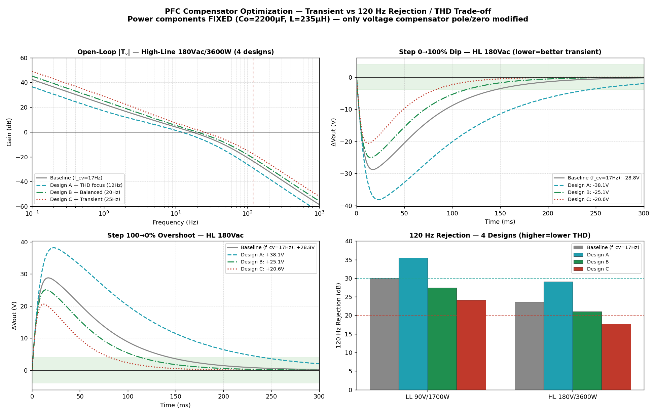
Figure 8 — Lowering f_cv improves THD/120 Hz rejection but worsens the transient; raising it does the reverse. Design C drops below 20 dB rejection at high line.
Note Recommendation: the Baseline (17 Hz) is already well balanced — 30/23.5 dB rejection with a 29 V worst-case dip. If THD is the priority, Design A (12 Hz) adds ~6 dB of 120 Hz rejection at the cost of a larger, slower transient. If transient response is the priority, Design B (20 Hz) cuts the dip and recovery by ~25% while keeping rejection ≥ 21 dB. Design C (25 Hz) is not recommended: its high-line 120 Hz rejection (17.7 dB) falls below the 20 dB minimum and would degrade THD. The current loop is left unchanged (crossover 8.12 kHz, PM 62.8°); its phase margin can be raised slightly by increasing the compensator pole f_p above 26 kHz if more current-loop margin is desired.
Decision Optimization — the baseline 17 Hz voltage loop is retained as the balanced choice. Design A (12 Hz) is the THD-optimal option and Design B (20 Hz) the transient-optimal option within the ≥20 dB rejection constraint; only the voltage compensator R2/C1/C3 change between them. Power components remain fixed.

Appendix A — Derivations of Key Transfer Functions
This appendix derives, from the averaged converter model, the two transfer functions the main report quotes: the boost small-signal plant (with its right-half-plane zero) and the OTA Type-III compensator. The aim is that a reader can reconstruct every plant and compensator expression used in Steps 13 and 14 without consulting the source application notes.

A.1 Boost Power Stage — Plant and the RHP Zero
Averaging the boost converter over a switching period and perturbing about the operating point (duty D, complement D' = 1−D = V_IN,pk/V_OUT) gives the standard CCM control-to-output relationship. The duty-to-output voltage transfer function carries one right-half-plane zero, one left-half-plane (ESR) zero and a complex pole pair:
$G_{vd}(s) = \frac{V_{OUT}}{D_{}^{′2}} × \frac{(1 + s/ωz_{ESR})(1 − s/ω{RHP}_{})}{1 + s/(ω0_{}Q) + s²/ω0_{}^{2}}$
The right-half-plane zero, the resonance and the quality factor evaluate to:
$ω_{RHP} = \frac{R_{LOAD} × D_{}^{′2}}{L_{eq}} , ω_{0} = \frac{D^{′}}{\sqrt{L_{eq}C_{O}}} , Q = D^{′} × R_{LOAD} × \sqrt{\frac{C_{O}}{L_{eq}}}$
THEORY The minus sign in (1 − s/ω_RHP) is the right-half-plane zero. Physically it is the boost converter's inability to source extra output current without first storing more inductor energy: raising the duty briefly steals charge from the output. It adds +20 dB/decade of gain but −90° of phase, so it can only be lived with, never compensated — hence the bandwidth ceiling.
INSIGHT For the two interleaved phases the effective inductance is L_eq = L/2, so ω_RHP is twice what a single phase would give. This is the quantitative reason the voltage loop in Step 14 can be placed where it is: interleaving pushes the RHP-zero ceiling higher.
For the inner current loop the relevant plant is the duty-to-inductor-current transfer function G_id(s); including the winding resistance r_L damps the resonance to the finite Q used in Step 13 (the lossless model would give Q → ∞). Its denominator is the same complex pair; its numerator places a low-frequency zero from the output network.

A.2 OTA Type-III Compensator
The voltage compensator is built around the FAN9672 transconductance amplifier (output current gm·v_in driving an impedance network). With the network of Figure 14A — R2 in series with C1, C3 in parallel, and the R3–C2 branch — the voltage-error-to-output transfer function has an integrator (pole at the origin), two zeros and two further poles:
$H_{OTA}(s) = \frac{g_{m}}{C_{1} + C_{3}} × \frac{(1 + sR2C1)(1 + s(R1+R3)C2)}{s (1 + sR2 · C1C3/(C1+C3))(1 + sR3C2)}$
Matching this to the canonical Type-III form gives the pole/zero placement used in the design:
Singularity | Expression | Design value
Integrator pole | at origin | —
Zero f_z1 | 1 / (2π R2 C1) | 3 Hz
Zero f_z2 | 1 / (2π (R1+R3) C2) | 12 Hz
Pole f_p1 | (C1+C3) / (2π R2 C1 C3) | 50 Hz
Pole f_p2 | 1 / (2π R3 C2) | 17 Hz
CONCEPT A Type-III compensator places its two zeros below crossover to add up to +90° of phase boost right where the loop crosses 0 dB, then uses its two poles to restore the roll-off afterwards. That phase boost is what lets a 17 Hz loop still achieve >80° phase margin despite the integrator's −90° and the plant's lag.

Appendix B — Bill of Materials (Control Components)
External components that set the control behaviour, with the step that derives each. Power-train components (switches, inductors, bulk capacitor) are specified in the power-stage design and are listed here only where they enter the loop equations.
Designator | Value | Type / Rating | Tol. | Function (step)
R_RI | 11.5 kΩ | Thin film, 1/16 W | 1% | Oscillator — 70 kHz (Step 4)
R_FB1 | 3.63 MΩ | HV divider, ≥ 200 V | 1% | Output sense top (Step 5)
R_FB2 | 23.2 kΩ | Thin film | 1% | Output sense bottom (Step 5)
R_CS | 15 mΩ | Kelvin shunt, 3 W | 1% | Current sense (Step 6)
R_IAC | 6 / 12 MΩ | HV, ≥ 400 V | 1% | IAC line sense, FR/HV (Step 3)
R_RLPK | 12.1 kΩ | Thin film | 1% | Peak detector (Step 3)
R_IC | 120 kΩ | Thin film | 1% | Current comp gain (Step 13)
C_IC1 | 1.3 nF | C0G/NP0 | 5% | Current comp zero (Step 13)
C_IC2 | 51 pF | C0G/NP0 | 5% | Current comp pole (Step 13)
R2 | 143 kΩ | Thin film | 1% | Voltage comp R2 (Step 14)
R3 | 8.66 MΩ | Thin film | 1% | Voltage comp R3 (Step 14)
C1 | 390 nF | Film | 5% | Voltage comp C1 (Step 14)
C2 | 1.1 nF | C0G/NP0 | 5% | Voltage comp C2 (Step 14)
C3 | 24 nF | Film/C0G | 5% | Voltage comp C3 (Step 14)
PITFALL Use C0G/NP0 or film dielectrics for every compensator capacitor. Class-II ceramics (X7R and worse) lose 20–80% of their capacitance with DC bias and temperature, which would shift the carefully placed pole/zero frequencies and erode phase margin in the field.

Appendix C — Bench Verification and Test Plan
Each headline result in this report has a corresponding bench measurement. Performing these closes the loop between calculation and hardware and is the basis for design sign-off.
C.1 Loop gain — phase and gain margin
ON THE BENCH Inject a small disturbance across a 10–50 Ω resistor placed in the feedback path and measure the loop gain with a frequency-response analyzer (Bode 100, or equivalent). Measure the current loop (expect crossover ≈ 8.1 kHz, PM ≈ 63°) and the voltage loop (expect 17 Hz / 82° at high line, 7.8 Hz / 81° at low line). Sweep both line and load corners and confirm the trends in Steps 13–14.
C.2 Load-step transient
ON THE BENCH Apply 0→100% and 100→0% electronic-load steps at low and high line. Capture bus deviation and recovery time with an AC-coupled probe. Expect a worst-case dip near 7.3% (28.9 V) recovering within ~150 ms (Step 15); confirm the response is monotonic, with no ringing, consistent with the >80° phase margin.
C.3 Input-current THD and 120 Hz rejection
ON THE BENCH Measure input-current THD with a precision power analyzer across line and load. Expect the loop contribution to track the 120 Hz rejection of Step 16 (30 dB low line, 23.5 dB high line). Separately verify the bus 120 Hz ripple amplitude against the Step 16 prediction (2.6 V low line, 5.5 V high line).
C.4 Brown-in / brown-out and start-up
ON THE BENCH Ramp the AC line up and down slowly and record the start and stop thresholds (expect brown-in ≈ 86.7 Vac, brown-out ≈ 47.9 Vac, Step 12). Apply IEC 61000-4-11 and SEMI F47 voltage dips and confirm ride-through without nuisance shutdown.
Note Record all measurements against the predicted values in a sign-off table. A deviation beyond component tolerance usually points to a modelling assumption (ESR, sense filtering, or layout parasitics) worth revisiting rather than a calculation error.

Appendix D — References and Further Reading
Primary sources for the equations and methods used in this report:
Ref | Source
[1] | ON Semiconductor, FAN9672 / FAN9673 Interleaved Dual-Channel PFC Controller — Datasheet.
[2] | ON Semiconductor, AN4165-D — Design Guidelines for the FAN9672 Interleaved PFC Controller.
[3] | ON Semiconductor, AND9925-D — Average Current-Mode Control and Small-Signal Modelling of the PFC Boost Stage.
[4] | Texas Instruments, SLVA662 — Type-III Compensator Design with a Transconductance (OTA) Error Amplifier.
[5] | R. W. Erickson and D. Maksimović, Fundamentals of Power Electronics, 3rd ed. — boost small-signal model, RHP zero, feedback design.
[6] | L. H. Dixon, Average Current-Mode Control of Switching Power Supplies — Unitrode/TI application note.
[7] | IEC 61000-3-2 (input-current harmonics) and IEC 61000-4-11 / SEMI F47 (voltage-dip immunity).
INSIGHT For the reader new to the field, [5] (Erickson & Maksimović) is the canonical text for the plant derivations in Appendix A, and [6] (Dixon) is the original and most readable treatment of the average current-mode current loop in Step 13.

Appendix E — Equation Quick-Reference Card
The working equations of the report on a single card, with the result each produces. Symbols are defined in the Nomenclature.
Current loop (Step 13)
Quantity | Expression / result
RHP zero (per phase) | f_RHP = R_LOAD · D'² / (2π L)
Plant resonance / Q | f_o = D'/(2π√(L_eq C_O)), Q set by r_L
Compensator zero / pole | f_z = 1/(2π R_IC C_IC1) = 1.02 kHz, f_p = 1/(2π R_IC C_IC2) = 26 kHz
Crossover / margin | f_ci = 8.12 kHz, PM = 62.8°
Voltage loop (Step 14)
Quantity | Expression / result
Loop gain | T_v = (K_max·I_OUT/V_RAMP) · G_i,cl · G_vp · H_OTA
Feedback divider | H_v = V_FBPFC / V_OUT = 0.006350
Comp zeros / poles | f_z1=3, f_z2=12 Hz; f_p (origin), f_p1=50, f_p2=17 Hz
Crossover / margin | f_cv = 17 Hz (HL) / 7.8 Hz (LL), PM ≈ 82°
Performance (Steps 15–16)
Quantity | Expression / result
Load-step dip | ΔV_OUT(s) = −ΔI · Z_open(s)/(1+T_v(s)); worst case 28.9 V (7.3%)
Bus 120 Hz ripple | V_ripple,pk = P_OUT/(2 ω_line V_OUT C_O) = 2.6 / 5.5 V
120 Hz rejection | −20 log10|T_v(j2π·120)| = 30 / 23.5 dB
THD₃ (loop contribution) | ≈ 50 · V_EA,120 / V_EA ≈ 1.5 / 3.0 %
Decision End of report. Seventeen steps, both compensators derived and verified, transient and distortion characterised, and the design-space trade-offs quantified — a complete, reproducible control-loop design for the FAN9672 interleaved CCM PFC.

